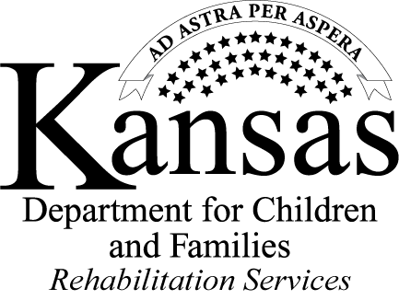
Work-Based Learning (WBL) Experience Final Report
Completed by Service Provider at completion of the WBL experience
Student Name: | WBL Site:
Pre-ETS Transition Specialist: | WBL Provider Completing the Final Report:
WBL start and end dates: | Hours Completed:
Describe introducing workforce programs and opportunities with the student.
The student’s strengths during the WBL.
Areas for improvement based on the WBL experience observations and feedback from employer.
Recommendations for training needs and accommodations, if any.
Any next steps in the field of interest agreed upon at the end of the WBL experience by the provider or employer including, but not limited to obtaining employment.

Identification of options for permanent employment based on the WBL experience.
Identification of any types of work environments not recommended for the student.
Other observations during the WBL experience and job preparation instructions.
01/14/2022

Work-Based Learning (WBL) Experience Final Report Instructions
Pre-ETS Transition Specialist: Name of the Pre-ETS transition specialist working with the student.

WBL Site: Employer site selected for WBL.

WBL Provider Completing Report: Name of the service provider working with the student and completing report.

WBL start date and end dates: When the student started the employment site and the last day or employment.

Hours Completed: The WBL hours the student completed.

