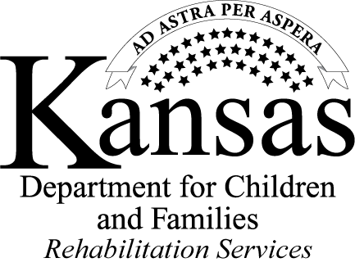

Request for Proposals

**Independent Living Services for Older Individuals who are Blind (OIB)**

Questions and Answers

October 3, 2012

Question 1: The RFP states that persons eligible for OIB services "are individuals who are age 55 or older whose significant visual impairments make competitive employment extremely difficult to attain but for whom independent living goals are feasible."  Does this mean if a person is not seeking employment (such as retired individuals) they are not eligible for services under this grant?

Answer 1: No. Individuals are NOT required to seek employment in order to receive OIB services.

Question 2: Is it expected that applicants will be applying for the entire period of February 17, 2013 - June 30, 2016?

Answer 2: Yes, it is the expectation that proposals will cover this entire time period. Please refer to the section titled “Award Amounts and Length” on Page 6 of the RFP. Budgets should be submitted for each of these three time frames:

* Projected funding statewide for February 17, 2013 through June 30, 2014 (time period #1) is approximately $477,889.
* Projected funding statewide for July 1, 2014 through June 30, 2015 (time period #2) is approximately $350,000.
* Projected funding statewide for July 1, 2015 through June 30, 2016 (time period #3) is approximately $350,000.

In addition, a grand total budget should be submitted that is the sum of these three time periods.

Question 3: Could the RFP documents be posted in Word in addition to PDF? This will make it easier to fill out the forms.

Answer 3: Yes, these have been added to our website at: [http://www.dcf.ks.gov/services/RS/Pages/RSpartners.aspx](https://dcfauth.dcf.ks.gov/services/RS/Pages/RSpartners.aspx)

Please note that applicants must complete Attachments A, B and C and submit them with your proposal.  Complete Attachment B in Excel format. Attachments D, E and F are post-award requirements.  Copies of these Attachments (D, E and F) are provided for the applicant's information and reference.  A statement of the applicant's intention to comply with Attachments D, E and F must be submitted with the proposal.

CONTINUED ON THE NEXT PAGE

*Strong Families Make A Strong Kansas*

Question 4: Our agency is on the Kansas side of the greater Kansas City metropolitan area.  There is a for-profit business that sells only products/assistive devices for low vision and blind individuals. The owner is very willing to collaborate with us to provide products/assistive devices at a greatly reduced rate.  The concern is that the location of the business is in Independence, MO.  Understanding that the OIB grant would provide services only for Kansans, would it be allowable for us collaborate with a company in Missouri to assist the Kansas clients?

Answer 4: Yes, this is permissible.

**Reminders**:

* The question-and-answer period for this RFP has now closed.
* The deadline to submit proposals is 5 p.m. October 22, 2012. Please be sure to follow the checklist on Page 11.
* Proposals must be submitted to:

Brie Wilkins, DCF Procurement

Docking State Office Building, 8th Floor

915 SW Harrison, Topeka, KS 66612

Email: [Brie.Wilkins@dcf.ks.gov](mailto:Brie.Wilkins@dcf.ks.gov)

* Be sure to review Priority Considerations beginning on Page 7 of the RFP.