WARDS ACCOUNT
Spend-Down Worksheet
Instructions

Complete this worksheet prior to contacting case manager to seek out additional needs of the client. If this worksheet reveals unreimbursed expenses are available for the spend-down, and that action brings the client’s account well under the limit, the worker does not also need to contact the case manager.

When a client who receives SSI is approaching the $2,000 resource limit, the worker needs to act to spend down the WARDS account. This spend down must occur before the 1st of the following month if no overpayment is to occur with the client’s SSI benefit.

The balance in a client’s account is determined by adding together ending balances in the regular account and the non-RD account. (Dedicated account balances do not apply to the $2,000 resource limit.)

Only expenses incurred while DCF was payee may be applied to a spend down. No permission is needed from Social Security to apply unreimbursed expenses incurred while DCF is payee to an account balance.

Step 1 Determine Dates DCF was Payee
This can be confirmed through review of the Social Security letters contained in the client’s WARDS file. If past correspondence is missing, use the month the first deposit was received by DCF as the Rep Payee start date.
NOTE: If more than one set of payee date periods are involved, complete a separate worksheet for each period. Example: Child in custody and OOH placement from 11/1/14-1/31/19, but another payee was involved with the case during that time period:
11/1/14-9/30/15 DCF Payee
10/1/15-5/31/16 relative payee
6/1/16-4/30/17 DCF Payee
5/1/17-7/31/17 benefit suspended
8/1/17-1/31/19 DCF Payee
Two separate PPS 5927A forms could be completed, one for 11/1/14-9/30/15 and one for 6/1/16-1/31/19.

Step 2 Confirm Service Months Missing
Run the Deposit Detail Report from WARDS for the dates involved in Step 1.

In this example, we were payee 6/1/17 thru current.
Please note that the first deposit was a lump sum so the agency has 9 months to spend down the $2205 before it counts against the SSI maximum limit. Take this into consideration when deciding if a spend-down is actually needed at this time.

Look at the From Date and End Date columns. Are all our Rep Payee months accounted for? No, September and October 2017 are missing.

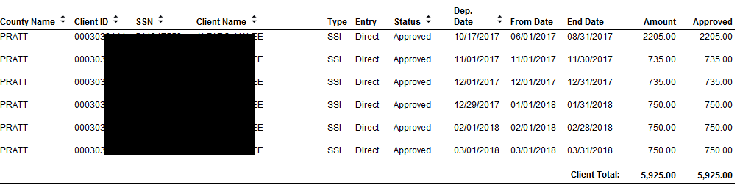

If service months are missing from the approved deposits, write the missing months on the worksheet and continue to next step.

If no months are missing, STOP. There is no further action you can take with this worksheet. Contact the Case Manager to see if there are additional unmet needs of the child.

Step 3 Seek Out Additional Expenses for Missing Months

Contact the WARDS System Administrator for a SCRIPTS listing of the expenses occurring during the missing months.

If there are no expenses that occurred during the missing month(s), there is no further action you can take with this worksheet – STOP. Contact the CWCMP spenddown contact to initiate a search for additional unmet needs of the child. The contact can also advocate for an increase in the relative’s stipend paid by the CWCMP when necessary.

If there are expenses available, review the report. You want to get the account down to a zero balance, so consider as many expenses as needed to get the account down to zero. Make note on this worksheet of the expenses you want to use.

Step 4 Request Manual Expense from WARDS Accountant

Complete request to WARDS Accountant at bottom of Worksheet and e-mail Worksheet with attachments (if applicable) to WARDS Accountant.
NOTE: If all the expenses listed in Step 3 will apply to the amount being requested for the manual expense, for the Reason type: “All expenses on Step 3 apply.”

