
Family Preservation Services Client Satisfaction Survey
PPS 4206 Acc
Apr-2026
Page 1 of 2

Instructions: Please fill out this short survey as accurately as possible. Your responses will be used to develop improvements to Family Preservation services.

Family Preservation services Worker Name:

 | Strongly Agree Not Disagree Strongly Agree Sure Disagree
1. My worker is a good listener. | 
2. My worker helped us find solutions to our problems.
3. Family Preservation helped us meet the needs of our children and family.
4. My worker or another Family Preservation worker responded when I needed her/him.
5. My Family Preservation worker met with my family at times that were convenient for us.
6. My worker helped us learn new skills to meet our family’s needs.
7. My worker helped connect us with other services my family needed. | 
8. I would work with my FPS worker again, if needed.

Tell us how we were most helpful to your family:

How could we improve our services to your family or other families?
Page 2 of 2

Thank you for completing this survey.

Optional Consent to Use Information:

The information in this survey above may be used by the Department for Children and Families Family Preservation services for program improvements, brochures, promotional literature, advertising or in similar ways. Only the initials of first and last name will be attached to the information if used for such purposes. I am at least 18 years of age and willing to sign below on this date, to allow the use of this information for promotional purposes.

Signature Date

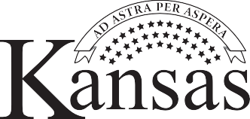
Department for Children and Families

