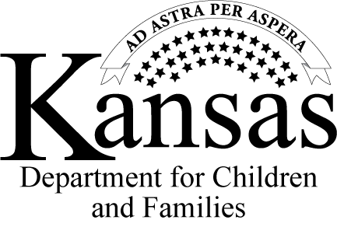
Referral for Services
Child Sexual Behavioral Problems
PPS 2014 B
REV Jan 21
Page 1 of 1

Attention Referral Agency: The Kansas Department for Children and Families (DCF) is providing this referral in accordance with K.S.A. 38 2290. Per K.S.A. 38-2290, upon DCF's receipt of a report of child abuse or neglect a child/youth having problematic sexual behaviors (defined in the statute), DCF shall immediately provide a referral of the child/youth to a child advocacy center or other mental health provider. Thank you for accepting this referral
and our agency is aware the ability to provide services is based on your agency’s capacity.
Case Number: |  |  |  | Event Number:
Date of Referral: |  |  |  | DCF Office:
TO: |  |  |  | FROM:
EMAIL: |  |  |  | TELEPHONE #:
CHILD’S NAME |  |  | DATE OF BIRTH
LOCATION OF THE CHILD
(NOTE: please do not include information to locate the child on parent’s copy if parents are unaware of the child’s location.)
PARENT/ CARE GIVER’S NAME
ADDRESS
CITY |  |  |  |  | ZIP CODE
TELEPHONE NUMBER
PARENT/CAREGIVER’S NAME
ADDRESS
CITY |  |  |  |  |  | ZIP CODE
TELEPHONE NUMBER
Distribution: An ✗ in the box indicates persons receiving a copy of this notice.
File | Parents/Caregiver of child |  | Child Advocacy Center |  |  |  | Mental Health Provider
Contractor Providing Services (If Applicable) |  |  |  |  |  |  | Other
Copy to FACTS

