EP Appendix D
WARDS User’s Manual

Updated June 2018



Contents
I. INTRODUCTION 5
A. Intended Use 5
B. History 5
C. Format 6
II. NAVIGATION BASICS 7
A. Installing WARDS 7
B. Signing In 7
C. Opening Screen Menu Options 7
D. Maneuvering Open Windows 11
E. Date Displays 11
1. Changing Dates 11
2. Pre-filled Dates 12
F. Running Reports 12
1. Selecting Report Criteria 12
2. View Report/Cancel Report 13
3. Saving a Report 13
4. Closing a Report 14
G. Searching in WARDS 14
G. Sorting in WARDS 14
H. User Roles 15
III. USER MAINTENANCE 15
A. Add Users 15
B. Change Password 17
C. Worker Caseloads 17
IV. HOW TO –REGIONAL OFFICE TASKS 18
A. Client Records 18
1. Add a New Client 18
2. Edit or View an Existing Client Record 20
3. Enter a Minimum Balance 21
4. Add New Rep Payee Date 21
5. Ending the Rep Payee Period 22
B. Approving/Disapproving Transactions 23
1. Approve/Disapprove Screen 24
2. Deposits 25
3. Expenses 27
4. Reset to Pending 27
C. Reports 29
1. Client List 29
2. Deposit Details 29
3. Expense Details 29
4. Expense Details by Service 29
5. Inactive Client List with Balance 29
6. Client Balance Range 29
7. Client Transactions Details 30
8. Client Interest Distribution 30
9. Notes/Activity 30
10. Rep Payee Reports-Submission 30
11. Rep Payee Tracking 30
12. Rep Payee Reports Log 30
13. Beneficiary List for Audits 31
V. HOW TO – DCF Administration TASKS 31
A. Making Deposits 32
B. Banking Processes 34
1. Batch Processes | Import Bank Statements 34
2. Transactions | Bank Import Corrections 35
3. Batch Process | Distribute Interest 35
C. Reconciliation 36
1. Regular Account 36
2. Dedicated and Non-RD Accounts 42
D. Reports | Finance 43
1. Bank Import Error List 43
2. Interest Distribution 43
3. Manual Deposits Details 43
4. Manual Expenses Details 43
5. Client Transaction Monthly Balance 43
6. Print Checks 44
7. Check Register 44
8. Checks Paid to CSS 44
9. Disapproved Amount Return to SSA 44
10. Checks Paid for Expenses 44
11. Interest Report (for 1099) 44
12. AFCARS Element 65 44
E. Writing Checks 44
1. Batch Processes | Return Disapproved Amounts to SSA 45
2. Batch Processes | Process CSS Returns [Discontinued Dec 2014] 46
3. Batch Process | Process DCF Reimbursement 47
4. Transactions | Manual Expenses 47
F. Voiding Checks 49
Appendix A - BGInfo 50
Appendix B – Reconciliation Confirmation Report 51
Appendix C – Technical Document – Interest Report for 1099 55
Appendix D – Technical Document – AFCARS Element 65 56
Appendix E – Banking – How to Download Regular Account Transactions 58

I. INTRODUCTION

A. Intended Use

This manual is intended to be a desk reference for WARDS users. It is not intended to be the sole source of information on policies and procedures related to WARDS. For full policies and procedures, see Prevention and Protection Services’ (PPS) Policy and Procedures Manual (PPM). You will find references to corresponding PPM sections throughout this manual.

B. History

Many youths who are in the custody of the Secretary for out-of-home placement receive, or may be eligible for, various benefits. DCF can initiate procedures with appropriate agencies to help clients receive benefits, and/or request to become payee of these benefits to help with the client’s cost of care. When DCF becomes payee, these benefits are managed through the WARDS system. WARDS is a database; the system was named WARDS due to children in foster care being wards of the State.

Historically, expenses for clients in WARDS had to be manually imported from SCRIPTS. This process is now automated. When a worker approves a deposit, if expenses for that service month are in SCRIPTS, they will automatically show in WARDS. When additional expenses are later imported into SCRIPTS, any expenses for previously approved deposits will also appear in WARDS.

The initial WARDS database was programmed in Microsoft Access. The current version of WARDS is programmed in .net and uses SQL server as a database. Special instructions must be followed when installing WARDS on a new computer so updates to the program are received automatically. See Appendix A of this manual for IT instructions.

C. Format

Part II of this manual provides an overview of navigation in the WARDS system. You will find tips on how to navigate in the WARDS system, as well as pictures and brief descriptions of the primary screens. If you are new to WARDS, follow along in this section for a quick tutorial. Note that different users have access to different screens, so some of the screenshots might not match exactly what you see on your screen.

In Parts III, IV, and V, you will find detailed instructions on specific actions in WARDS.

Note the following icons in section II and IV:
The “try it” icon suggests you perform a procedure so you can get a feel for it (primarily for new WARDS users);
The “STOP” icon offers a warning not to do something, along with an explanation as to why;
 The “pause” icon reminds the user that an action is permanent and suggests that you think twice to make sure you are certain before you complete the action.

Throughout the manual, you will see references to or excerpts from the PPM. These are only for your reference and are not intended to be a substitute for being familiar with the full policy and procedure.

Several appendices at the end of this guide have been added to assist in your work with WARDS and will be referenced throughout the manual.

II. NAVIGATION BASICS

A. Installing WARDS
The current version of WARDS is programmed in Visual Basic.Net 2012 and uses SQL server as a database. Special instructions must be followed when installing WARDS on a new computer so updates to the program are received automatically. See Appendix A of this manual for IT instructions.

B. Signing In
You were given a Login Name and Password. This is what you want to enter on the login screen.
Forgot your password? A WARDS user assigned an administrator role (possibly your supervisor) can reset your password.
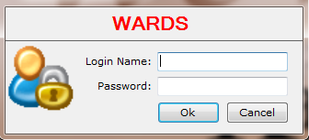

C. Opening Screen Menu Options
After you enter your login name and password, click <OK>; you will see the WARDS opening screen. At the top of the screen you will see this menu…
This menu is visible even when you have menu items open in WARDS. A menu option is selected by clicking on the title.
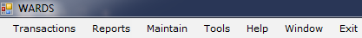

- Try It!

Click on the Transactions tab: 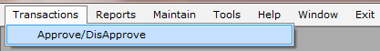
When you click on the Transactions tab, clicking on Approve/DisApprove will open a new screen. Close the screen by clicking the black “X” in the upper right corner of the screen.
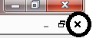

Clicking on 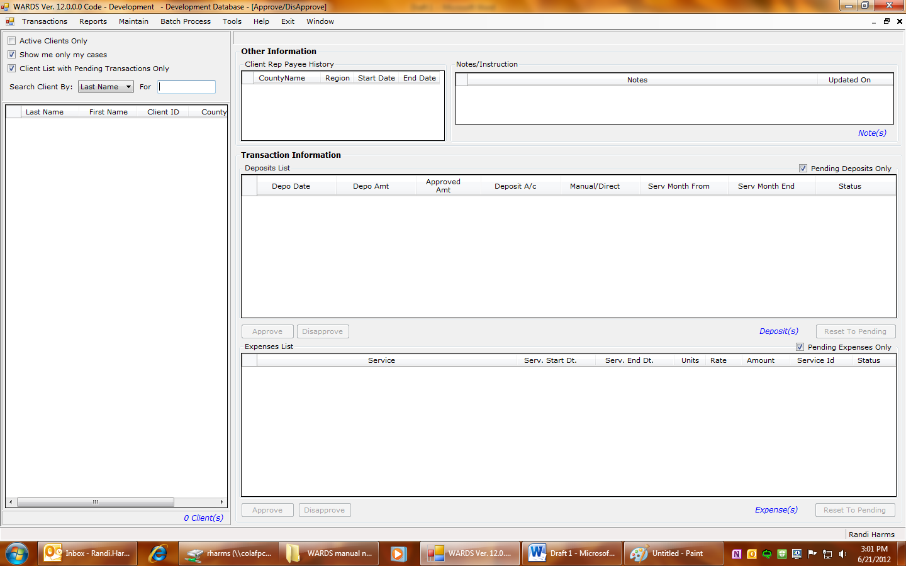 in the upper right corner of your screen will close WARDS.

Here is a brief overview of what is in each tab on the main menu (from left to right).
Note: These options are what a regional staff user would see on their screen. Additional menu items are available to Central Office users and are explained in Section V.

TRANSACTIONS

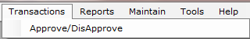

Approve/DisApprove: This screen allows the user to review information about a client’s incoming deposits and expenses. Deposits and expenses show a status of pending until the worker approves or disapproves them. Also on this screen are episodes where DCF is representative payee of the client’s benefits and any child specific notes.

REPORTS
Reports | Clients offer users a variety of ways to organize information- by region, by deposit/expense status, by total balance range, etc. These reports are useful in ensuring that deposits/expenses are approved in a timely fashion and ensuring that account balances stay within the appropriate limits (see PPM 5928 for information on balance limits). This option also assists the user in completing Representative Payee Reports. See section IV – How To-Regional Office Tasks for details on reports available.

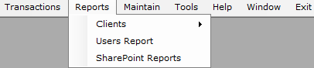

MAINTAIN
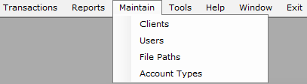
The Clients screen is used to enter new clients into WARDS, change the start/end dates that DCF is Rep Payee, or change worker/county/region information.
The Users screen is used to manage workers’ access to certain regions, their roles, password, etc. This is where a user would change their password. Only Administrator roles have access to update other users.
File Paths and Account Types are screens used by the System Administrator.

TOOLS

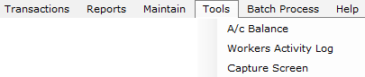

A/c Balance allows the user to review a client’s account balance(s) for a specified date. Workers Activity Log (available to administrators only) allows the user to view a particular user’s activity in the system. Capture Screen allows user to e-mail a screen print.

HELP

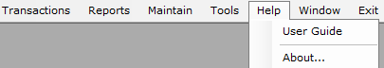

Access to the WARDS User’s Guide can be obtained any time you are logged on to WARDS by selecting Help | User Guide.

WINDOW
This option displays a list of all open windows. If you don’t have any windows open, there will not be any items in the list. If you have multiple windows open, you can navigate between them by selecting them from the list.

EXIT
Clicking Exit will close the WARDS database.

D. Maneuvering Open Windows
There will be times when you are working in WARDS that you may wish to look at one screen while entering information in another. It is possible to have more than one screen in WARDS open at the same time. You can toggle between screens by choosing the menu option “Window” and selecting the desired screen.
You can also move a screen around by placing the mouse cursor on the bar at the top of the window 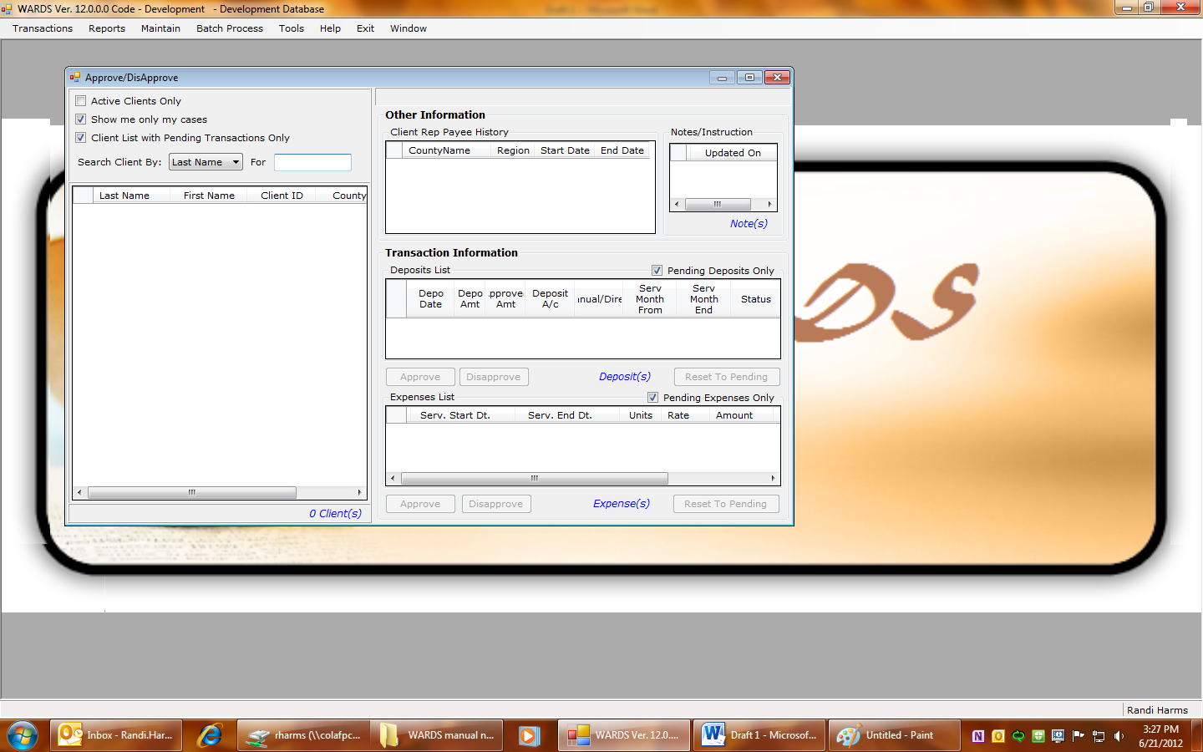 hold the left mouse button down and drag the window to a new location on the screen.

E. Date Displays

1. Changing Dates
Reports and other functions in WARDS allow the user to select a date. The standard date default will be the current date. There are two ways to change or select a date…
- Typing

Place your cursor on the first digit of the date field, type in the new number
- Calendar
Click the pull-down arrow to the right of each date field to have a calendar appear; select the date you desire.
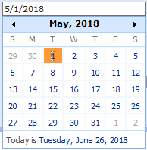

2. Pre-filled Dates
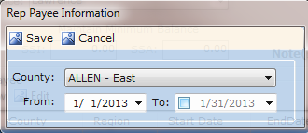
When you need to enter a date, for example to start a rep payee period, often the start date will be pre-filled. Any pre-filled dates can be changed.
Other date fields, like the “To” date shown here, will have a date displayed but it will be dimmed. If this dimmed date is desired, clicking the checkbox will make it appear as a non-dimmed date in the field; at this point you could also change the date. If the dimmed date is not selected, leaving it dim means the field has no date present.

F. Running Reports
Selecting a report from the Reports menu in WARDS will cause you to leave the WARDS application and will take you to the SharePoint site where the reports is created. The following instructions are for the SharePoint site.
- Selecting Report Criteria – Each report has its own criterion which allows you to filter the results displayed. The various option you may see are:
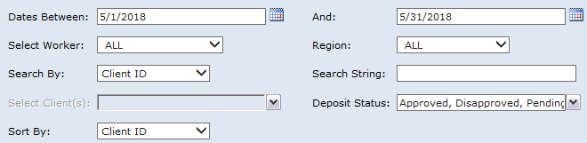
Date Range: Select by typing or using calendar feature.
Worker ID: ALL or specific worker.
Region: ALL or a specific region.
Search by: Last Name, Client ID, or SSN.
Search string: Enter search to narrow results, ie: ClientID = 0001234567 (NOTE: Include leading zeros for searches by client ID; all 10 digits must be present for the search to be successful.) After typing in the search criteria, hit <Tab>; this will make any matches appear in the Select Client(s) box. If more than one client appears, check ALL to select all of them or the specific client you wish to see.
Sort By: Select data sort by Client Name, Client ID, or SSN
After selecting all the criteria desired, click <View Report>.

View Report/Cancel Report
When a Report is loading after clicking <View Report>, while data is being gathered based on the search parameters, a popup window will display as follows.

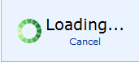
If you want to cancel the action, you can click on Cancel in the popup window. The search will be discontinued and the screen will redisplay ready for a new set of search parameters to be selected.

- Saving a Report – After running a report, the report will display on the screen. You have several options to save the report. Supported options are:
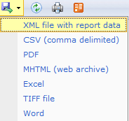
CSV (comma delimited) – this option is editable and will open in Notepad or Excel

PDF – this option is not editable and will open in a pdf reader

Excel – this option is editable and will open in Excel

Once making your choice, an option bar will appear at the bottom on your screen, asking if you want to <Open>, <Save>, or <Cancel>.

- Choosing <Open> will make the report open in the program chosen.
- Choosing <Save>, click the down arrow on the Save selection and choose, Save As which opens a window for you to save the report.
- Choosing <Cancel> returns you to the completed report screen.

Closing a Report
Click the Exit button to close the report. Note that clicking on the “X” in the Client Report Window will also close out the report.

G. Searching in WARDS
Various screens in WARDS allow you to search for a person. Here is the search feature on the Approve/Disapprove screen:

By clicking the pull-down menu for “Last Name” you see the various search options:
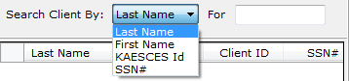

When you type in the field “For”, entries matching your criteria will appear in the space below.
NOTE: When searching by KAECSES ID, you DO need to type in the leading zeros.
This search feature is similar on other screens.

H. Sorting in WARDS
All tables that appear on the screens of WARDS have columns that are sortable. In this example from the Approve/Disapprove screen, by clicking on the column heading “Client ID,” the table became sorted by client ID, smallest to largest.
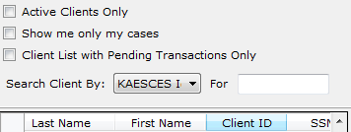

I. User Roles
Following are the roles available for use in WARDS. For all users, access to one or more region can be assigned:
Regional Office Viewer – View only access to menu options available to a Regional Office User.
Regional Office User – Update capability for approving/disapproving transactions and maintaining client information. Menu options available are Transactions, Reports, Maintain, Tools, Help, Window, Exit.
Regional Office Administrator – Same access as Regional Office User PLUS can add new users to the system. When assigning access to regions, can only assign access to regions for which they have been granted access.
Central Office Viewer – View only access to menu options available to a Central Office User.
Central Office User – Update capability for approving/disapproving transactions, maintaining client information, and performing batch processes. Menu options available are Transactions, Reports, Maintain, Tools, Batch Processes, Help, Window, Exit.
Central Office Administrator – Same access as a Central Office User PLUS can add new users to the system.
Power User – Complete access to all system menus; reserved for the WARDS Administrator and programmer.

III. USER MAINTENANCE

A. Add Users
To add a new user: (NOTE: only Administrator roles allow this function)
- Send the Business Help Desk (DCF.HelpDeskBusiness@ks.gov) an e-mail with the following message: Please add (user name and Outlook e-mail address) to WARDSApp group.
- In WARDS, select Maintain | Users
- Click <New>. A window opens to enter the new user’s information.
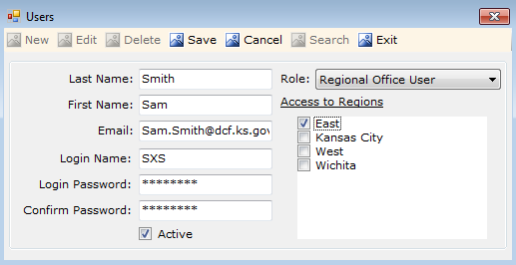
Last Name = Enter last name as it appears in Outlook
First Name = Enter first name as it appears in Outlook
Email = Enter Outlook email address
Login Name = Enter User Name as displayed on BGInfo screen (see Appendix A for how to locate BGInfo)
Login Password = no restrictions
Confirm Password = type password again; must match first attempt
Active = If this user is an active user, check the box. Active means the user is currently using WARDS.
Role = See Section II for definition of the various user roles available.
Access to Regions = Check the regions this user needs access to. The administrator entering a new user into WARDS cannot assign more regions than they have been assigned.
4. Enter user information. Click <Save>.
5. Once ITS has added the user to the WARDSApp group, the user can install WARDS from Internet Explorer’s DCF Home Page (http://dcfnet.dcf.ks.gov/Pages/Home.aspx).
Click on the Applications icon,  . Scroll down to WARDSNet, click on the P and follow the online instructions to install the application on the user’s computer.

B. Change Password
All users can maintain their own access to WARDS by changing their password or name spelling, for example. If a user forgets their password and is unable to sign on to WARDS, an administrator can assign a new password to a user.
To view or edit a current user:
1. Select Maintain | Users
2. Click <Search> to locate the user.
3. With user showing on screen, click <Edit> to make changes.
4. Make needed changes. Click <Save> to save your changes, or <Cancel> to exit edit mode without saving any changes.

C. Worker Caseloads
The WARDS worker assigned to a case is established on the Maintain | Clients screen. See section IV for how to edit or view an existing client record; this screen is where you would add or change the worker assigned to the case.
To view a listing of all cases and worker’s assigned, view Reports | Clients | Client List. Run the report for your region and then save it as a spreadsheet to sort and view workers assigned to each client. See Section IV.C for details on how to run reports.

IV. HOW TO –REGIONAL OFFICE TASKS
This section contains instructions pertaining to tasks performed by the regional office user. Central office users’ duties will require some of these same instructions. For more information on central office tasks, see section V of this manual.

A. Client Records

1. Add a New Client

Regional office staff shall enter new clients into WARDS upon receipt of the letter from Social Security saying DCF has been made payee. It will be important for the client to be entered into WARDS prior to the first direct deposit received, so try to enter the client into WARDS within 10-20 days of receipt of the awards letter.

1. Select Maintain | Clients
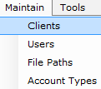

2. On the screen that opens, click Search to make sure your client is not already in WARDS. If not found, click New.
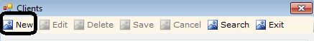

- Fields will become enterable, but client information is taken from SCRIPTS.
- Enter Client ID without leading zeros
- Hit <tab> (the system will check SCRIPTS); if there is a match, WARDS will populate the other fields with the client’s information. If no match is found, contact the WARDS Program Administrator or System Administrator for assistance.
- SSA ID 1 is where the Claim Number is entered from the letter (see example here):
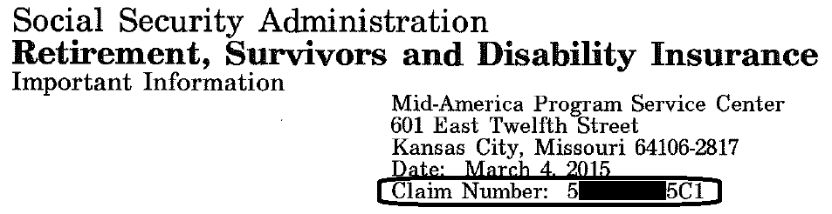
No dashes or spaces are entered; type the number just as it appears on the letter making sure to include the C1 or whatever letter/number combination appears at the end of the social security number. This claim number allows for WARDS to assign that direct deposit to the right client. NOTE: If your client was already known to the system, but this is a second awards letter with a different claim number, leave the number displaying in SSA ID 1 and enter this new number in SSA ID 2.
- Select a Worker from the pull-down menu. If worker is not shown in the pull-down menu, add worker to Maintain | Users and then proceed.
- A Social Security office is chosen by the system based on the county of court commitment. If a different Social Security office applies, make that change from the pull-down menu. If this client’s benefits are not from Social Security select “none”.
- Click <Save>.
NOTE: When the client is age 18-20, the system will display the message, Warning – Client is age 18 to 20. Do you want to add this client? Press “Yes” to continue or “No to exit. This warning was added to ensure only foster care clients are added to the system.
NOTE: If client is over the age of 21, a popup box opens with the error: Client is 21 or over. This client cannot be entered. This warning was added to ensure only children, no adults, are added to the system.

5. On the Rep Payee section, the system assigned a county and region based on referral information in SCRIPTS. If this needs to be changed, click <Edit> to make changes.
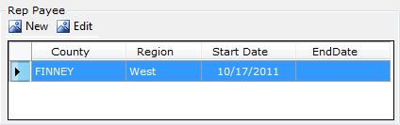

6. CSS Information Section – No Longer Used.
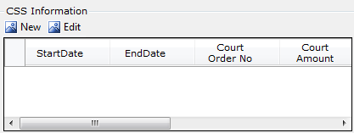

2. Edit or View an Existing Client Record

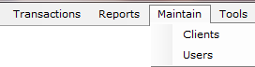
- Select Maintain | Clients

- Search and locate the desired client record.
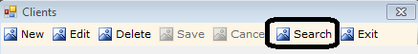

- With the selected client’s information displayed on the screen, click <Edit> to make changes to the client details.

- Click <Save> to save your changes, or <Cancel> to exit edit mode without saving any changes.

Try it!
Search for the record for client Kayla A Monroe using last name.

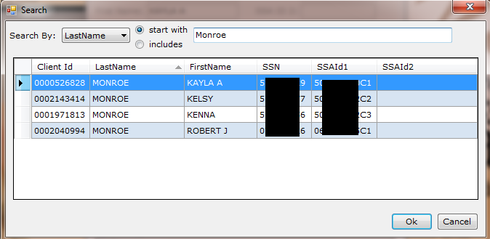

3. Enter a Minimum Balance
When a minimum balance is entered, that amount will be conserved and not used to reimburse the agency for expenses. See PPM Section 5928.E for policy regarding setting a minimum balance.
- Go to Maintain | Clients
- Click <Search> to locate the client.
- With client information showing on the screen, click <Edit>.
- Enter the minimum balance in the box for the appropriate funding source (SSI or SSA).
- Click <Save> to save the change.

It is easy to forget a minimum balance has been set. Several reports display a client’s minimum balance, including the Client List report. It is important to periodically review minimum balances set for clients in your caseload and confirm they are still needed. If ever it appears approved expenses are not being reimbursed to the agency, check to see if a minimum balance has been set. Removing the minimum balance will allow the system to reimburse DCF once again.

4. Add New Rep Payee Date
Any time DCF is made representative payee of a benefit for a child in DCF custody, a new Rep Payee date is entered in WARDS. It is these start and end dates that allow certain functions within WARDS to occur, i.e., a deposit can only be approved if the transaction date of that deposit falls within a Rep Payee episode.
- Go to Maintain | Clients
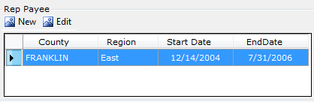
- Search and find the client.
- In the Rep Payee section of the screen, select the segment you need to update and click <edit>.

OR

If you need to enter a new segment, make sure all previous segments are ended and click <New>.
d. Clicking “New” or “Edit” will open a screen on which you can make the needed changes.
e. Once changes have been made, click <Save>.

5. Ending the Rep Payee Period
a. Importance of Entering Rep Payee End Dates
When DCF is no longer representative payee of a benefit, an end date needs to be entered for the current Representative Payee episode. This end date to a Rep Payee period is very important for tracking benefits and for audit purposes. When an end date is present, the system knows not to distribute interest to that account because the balance will be returned soon. The end date also assists the user because the system will not allow the user to approve a deposit which is received after the end date. [If the user wants to approve a deposit received after an end date has been entered, the user can remove or change the end date and then approve the deposit.] The end date to a Rep Payee period also assists supervisors and workers in knowing worker caseload; when an end date is present the case is not considered “active” by the system.
(Note: When a Rep Payee end date is present, the Client List report will not display the client when the option “Active Cases Only” is selected and the run date of the report is after the Rep Payee end date. On the Approve/Disapprove screen, the client will no longer be displayed in the client list when “Active Clients Only” is selected and no pending transactions exist.)
b. Deciding What End Date to Use
The Rep Payee period shall end at the end of the month…
- in which DCF is no longer eligible to be representative payee of the benefit (i.e., the child returned home, was released from DCF custody, or was transferred to JJA or tribal custody) . When the benefit is from Social Security, a GSO Reporting Form, PPS-5928, shall be completed; see PPM section 5928 for details on when the form is completed; or
- when a letter is received informing there’s been a change in payee (ex. placed with a relative and Social Security made the relative payee) …
whichever comes first.
For Social Security benefits, there may be timing issues and Social Security may continue to send DCF benefits after we are no longer eligible to be payee and you have entered an end date to the Rep Payee period. Sometimes the benefit is for past months when the child was out of home and DCF is eligible to receive it; those benefits you can change the service dates involved with the check (after receiving approval to do so—see PPM section 5928.C.2). If extra benefits we are not entitled to are received after the end date of a Rep Payee period, disapprove the deposit so it can be returned to Social Security. If Social Security sends the returned benefit back to DCF, contact Social Security to inform them of the problem.
c. Procedure in WARDS
- Go to Maintain | Clients
- Search and find the client.
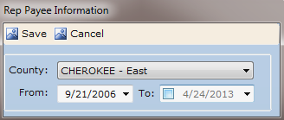
- In the Rep Payee section of the screen, select the segment you need to update and click <edit>. Clicking “Edit” will open a screen on which you can add an end date.

- Once the end date has been added, click <Save>.

B. Approving/Disapproving Transactions

Benefits received through direct deposit or made manually are put into one of the three bank accounts. Once there, they appear as “pending” on the Transactions | Approve/Disapprove screen. Users must approve deposits before expenses for that benefit month will load. When a deposit is approved, expenses, if present, for the service dates involved with that deposit, automatically load into WARDS. Expenses, or encounters, are taken from SCRIPTS (Statewide Contractor Reimbursement, Information, and Payment Tracking System) and generally are available after the 25th of the following month. For example, expenses for January are available after February 25th.
There are two types of expenses in WARDS: those you request and those received from the foster care contractor as encounters. Those received from the foster care contractors and marked as approved are used to reimburse the agency for the client’s cost of care.
See PPS PPM Section 5929 for guidelines on when to approve deposits, when to approve expenses, and how to correct an expense displayed incorrectly in WARDS.

1. Approve/Disapprove Screen
To display only your caseload so you can find a client for which you want to approve/disapprove a deposit or expense, do the following:
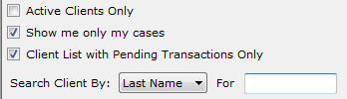
a. Click on Transactions | Approve/DisApprove.
By default, the screen will display only clients assigned to you and only those clients who have pending transactions.

These settings can be changed by clicking on the checkmark to remove it.

b. If the client is not displayed, use the search feature to find the client record you desire. If you are still having difficulty locating the client you seek, remove all checkmarks from the boxes above so no filter exists. (NOTE: If client is still not found, go to Maintain | Client screen and search for client to see if client is assigned to your region and to you as their worker.)

c. Select the client. Notice the Transaction Information is split into two sections: Deposits List and Expenses List. Deposits and expenses that have not been approved or disapproved are labeled as Pending.

d. Uncheck the box next to Pending Deposits Only and/or Pending Expenses Only to see previously approved and disapproved expenses and deposits. Doing this will allow you to ensure that a duplicate entry has not occurred.

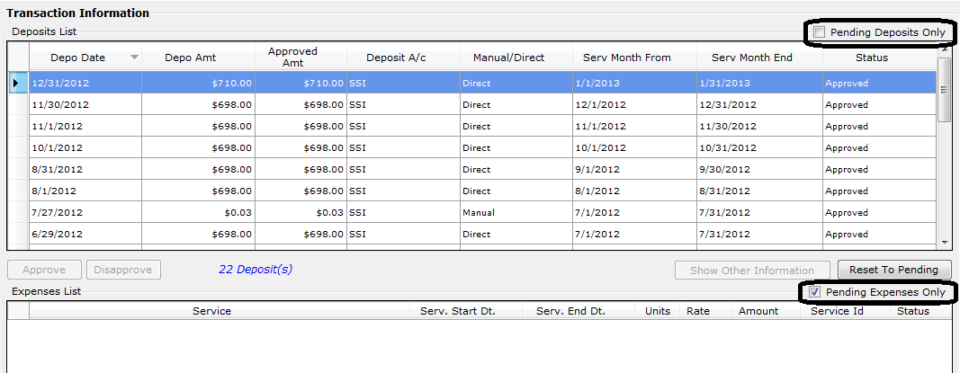

2. Deposits

To approve or disapprove a deposit, select the pending deposit by clicking on it, then click “Approve” or “Disapprove”.
- If approving full amount, check the service dates applied to the deposit; make changes, if necessary; then click <Save>.
Multi-month Distribution – PPM section 5928 explains the process for having a lump sum deposit approved for a multi-month distribution (applying the deposit to expenses spanning several months). Leave the deposit in a pending status. Once the request is approved by Social Security, change the service dates before approving the deposit.
How to apply multiple months to a deposit:
- Select the pending deposit.
- Click <Approve>.
- The window that pops up will allow you to change the service dates associated with the deposit (labeled as ‘Deposit From’ and ‘Deposit To’).
- After changing the dates, click <Save>. If expenses do not appear immediately for the date span entered, wait overnight and check again.

- If approving a partial amount, change the amount (see black arrow in screen shot below), press tab, then enter the necessary information in the box that appears. Click <Save>. This additional information tells the WARDS clerk where to return the disapproved amount of the deposit.
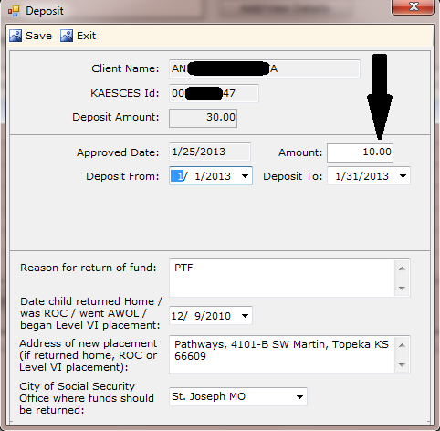
Once a deposit has been approved and expenses paid against that deposit, you cannot revert it back to pending. Be sure that the amount and dates are correct and that you do indeed want to approve this deposit before clicking save.

- If disapproving the full deposit, click Disapprove and enter required information in the box that appears; click “Save”.
Once a deposit has been disapproved and sent back to the issuer, you cannot revert it back to pending. Be sure that you want to disapprove the entire deposit before clicking save.

3. Expenses

To approve or disapprove an expense, select the pending expense by clicking on it, then click “Approve” or “Disapprove”.
- If approving, click <Save>.
Once an expense has been approved and reimbursed to DCF, you will not be able to reset it back to pending. Be sure the expense type and amount are correct and that you do indeed want to approve this expense before clicking save.
- If approving a different amount, after clicking “Approve”, a box appears with the details of the expense (see screen shot below). If you have determined the units, rate, or service start/end dates need corrected, change the needed fields and then click <Save>.
NOTE: See PPS PPM Section 5929 for details on when and how to correct an expense.
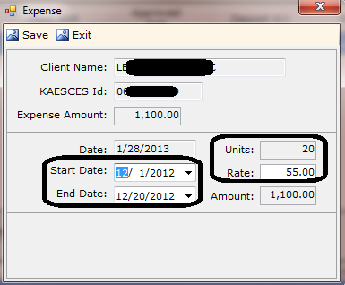

- If disapproving, click Disapprove. You cannot change any information in the detail box that pops up. Click <Save>.
NOTE: Disapproved expenses can always be reverted back to pending.

4. Reset to Pending
If you approve or disapprove a deposit or expense in error, you may be able to reset the status of the transaction back to pending.

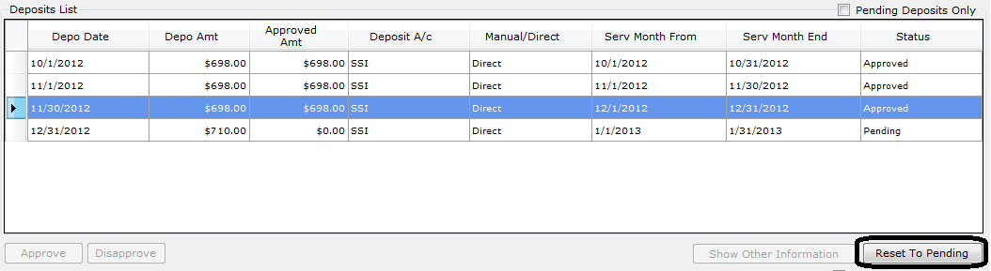

a. On Transactions | Approve/DisApprove screen, select the deposit or expense you wish to reset to pending.
b. Click “Reset to Pending”.
c. A message will appear asking if you are sure you want to reset the transaction to pending; select <Yes>. If the transaction can reset to pending, the status will change back to ‘pending’.
d. If the system is unable to reset the transaction back to pending an error message will appear due to the following situations:

  - Deposits: A payment has been made against an approved deposit; or a disapproved deposit was returned Social Security.
  - Expenses: An approved expense has been applied as reimbursement to DCF for that month.

If you are unable to revert a transaction back to pending, and the approved and/or disapproved deposit or expense will adversely affect the client’s account, do the following:
- Approved Deposits - Notify DCF Finance that the deposit was approved in error. Explain if only a partial amount should have been approved or if the entire deposit should have been disapproved. DCF Finance can reimburse the WARDS account if the benefit should have been returned to Social Security or some other entity.
- Disapproved Deposit – The deposit has been returned to the agency or individual you indicated it should be returned to. Contact DCF Finance to see if the return has been mailed yet. If it has, you will need to contact that agency or individual about having the money returned.
- Approved Expenses – This means you approved an expense that was incorrectly submitted by the foster care contractor. Consult PPS PPM Section 5929 about how to correctly handle this type of situation in the future. For this current expense, since you approved it and the system will not allow it to be reverted to pending, there are two things required of you:
- Ask the contractor to submit the correction under the same service ID. This will allow SCRIPTS to get corrected information, but not cause a duplicate expense in WARDS.
- Contact DCF Finance about having the amount of that expense re-deposited into the client’s account.

C. Reports
There are many reports in WARDS to help you manage your work. Here is a listing of the reports available from the Reports | Clients menu. When a report is listed a second time followed by the words “Excel Export”, it means the first listing should be selected when a printed, formatted report is desired; the second listing with “Excel Export” should be selected when the user needs the information saved in an Excel spreadsheet.
1. Client List – The Client List report provides a list of clients, active or all, for all workers or a selected worker, for all regions or a selected region.
2. Deposit Details – The Deposit Details report provides a list of deposits received and their status as per the filters applied.
3. Expense Details – The Expense Details report provides a list of expenses as per the filters applied.
4. Expense Details by Service - The Expense Details by Service report provides a listing of all clients receiving the selected service as per the filters applied.
5. Inactive Client List with Balance - The Inactive Client List with Balance report provides a list of clients who do not have an open rep payee episode as per the filters applied.
6. Client Balance Range - The Client Balance Range provides a list of client with balances falling within the filters applied. Use this report to monitor clients that may be approaching the $2,000 limit for SSI.
7. Client Transactions Details - The Client Transaction Details report shows transactions which have occurred and the monthly ending balances during the time period specified. This report also displays if a minimum balance has been set for the client
8. Client Interest Distribution – The Client Interest Distribution report shows the balance in a client’s account and the amount of interest distributed to that client’s account by transaction date.
9. Notes/Activity - The Notes/Activity report shows all notes and activities for the clients specified for the time period specified. Notes are the user entered narratives; activities are changes made to the client’s case through the system, i.e., approving a deposit, changing the worker to the client, etc.
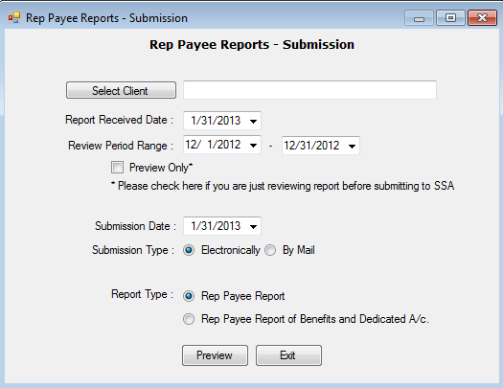
10. Rep Payee Reports-Submission - Running the Rep Payee Report in WARDS produces the answers needed for the worker to complete the Representative Payee Report received from Social Security.
When running the report, you can preview the answers by putting a checkmark in the Preview Only box. Checking this box means you do not need to provide a submission date—you are only previewing the answers to the report. Information put on this screen is used in the Rep Payee Reports Log report.

11. Rep Payee Tracking – The Rep Payee Tracking report is used by users and supervisors to monitor WARDS caseloads. The report shows all clients with open Rep Payee episodes on the date specified.
In the example below, the first client has a Rep Payee episode starting 10/5/10 but has never received a deposit. Seeing this entry on this report would cause a supervisor or worker to research this client to find out why DCF never received a deposit and possibly end the Rep Payee episode since he is not an active client in WARDS.
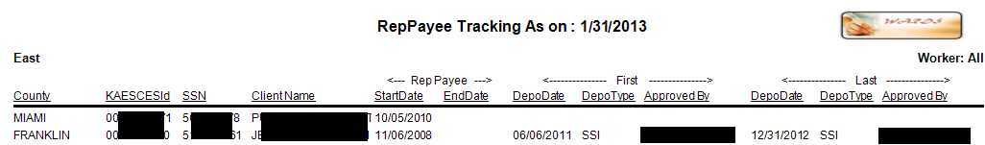

12. Rep Payee Reports Log –The Rep Payee Reports Log can only be run by someone with a supervisor role in WARDS. By selecting a particular worker, the supervisor can see a log of Representative Payee reports received and submitted by the worker. This report may assist with worker performance evaluations.
13. Beneficiary List for Audits - Run this report for any local Social Security audit. This report provides a list of clients from a selected county who received SSI or SSA during the period under review, provides their account balance on a specific date, and displays where they are placed today (as known to FACTS).

V. HOW TO – DCF Administration TASKS
This section contains instructions pertaining to tasks performed by the central office user. Refer to Section IV of this manual for tasks that are also performed by the regional office user, represented in the chart below with an “x” in the Regional Office Role column.
Menu Options Available to… | Central Office Role | Regional Office Role
Transactions | Approve/DisApprove | x | x
Transactions | Manual Deposits | x
Transactions | Manual Expenses | x
Transactions | Void Check | x
Transactions | Bank Import Corrections | x
Transactions | Reconciliation Corrections | x
Transactions | Bank Reconciliation-Reg Acct | x
Transactions | Bank Reconciliation-nonReg Acct | x
Reports | Finance | Bank Import Error List | x
Reports | Finance | Manual Deposits Details | x
Reports | Finance | Manual Expenses Details | x
Reports | Finance | Print Checks | x
Reports | Finance | Check Register | x
Reports | Finance | Checks Paid to CSE | x
Reports | Finance | Disapproved Amt Rtrn SSA | x
Reports | Finance | Checks Paid for Expenses | x
Reports | Finance | Interest Report for 1099 | x
Reports | Finance | AFCARS Element 65 | x
Reports | Clients | Client List | x | x
Reports | Clients | Deposit Details | x | x
Reports | Clients | Expense Details | x | x
Reports | Clients | Expense by Procedure Code | x | x
Reports | Clients | Inactive Client List w/Balance | x | x
Reports | Clients | Client Balance Range | x | x
Reports | Clients | Client Transactions Details | x | x
Reports | Clients | Notes/Activity | x | x
Reports | Clients | Rep Payee Rpts – Submission | x | x
Reports | Clients | Rep Payee Tracking | x | x
Reports | Clients | Rep Payee Reports Log | x | x
Maintain | Clients | x | x
Maintain | Users | x | x
Tools | A/c Balance | x | x
Tools | Workers Activity Log | x | x
Batch Process | Import Bank Statements | x
Batch Process | Import Exp | Export Client List | x
Batch Process | Import Exp | Load Expenses | x
Batch Process | Return Disapproved Amt SSA | x
Batch Process | Process CSE Returns | x
Batch Process | Process SRS Reimbursement | x
Batch Process | Distribute Interest | x
Help | Contents | x | x
Help | Index | x | x
Help | Search | x | x
Help | About… | x | x
Window | x | x
Exit | x | x

A. Making Deposits
Deposits are made into a WARDS account in one of two ways: manually or through direct deposit. How direct deposits appear in WARDS is discussed in the next section. When a paper check is received for deposit into WARDS, the Manual Deposits menu option is used to deposit the check into the correct account (see PPS PPM Section 5927.D for a description of the different bank accounts in WARDS).
If multiple checks need to be deposited into more than one account, separate the checks into piles for each account type: Regular, non-RD, Dedicated. Do a manual deposit for each account type.
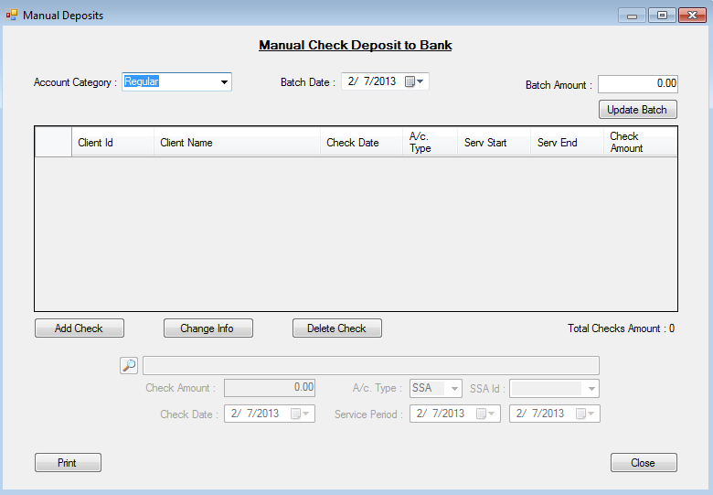
- Account Category – Select Regular, Dedicated, or Non-RD from the pull-down menu.
- Batch Date – Pre-filled with today’s date.
- Batch Amount – Type in the total of all checks needing deposited into this account.
The total amount of each individual check entered must equal this Batch Amount.
- Enter each individual deposit – clicking <Add Check> will make the check detail section of the screen fillable. Enter the details of the check:
  - click the search icon to select the client for whom the deposit is for;
  - use the actual date written on the check for the Check Date;
  - if account type is SSA, select the SSA Id. (On client maintenance screen this was the SSA ID1 or SSA ID2 number entered…if it hasn’t been entered on client maintenance yet you won’t see it as an option; go to Maintain | Client and enter the SSA ID1 from the check so you will have it as an option on this screen.)
  - The service period will pre-fill based on the date of the check. Make changes if needed.
  - Click <Save>.
  - Message appears that check has been updated. Click <OK>. Check appears on screen.
  - Enter next check until all checks have been entered. The total of all checks at bottom of screen must equal the Batch Amount before batch can be updated. If a mistake was made on one of the check entered, select that check, click <Change Info> and make the correction, making sure to save the change. If the batch amount was entered incorrectly, enter the correct Batch Amount.
  - Once the Batch Amount and the Checks Total Amount match, click <Update Batch>.
  - A message appears reminding you to approve/disapprove the added deposits.
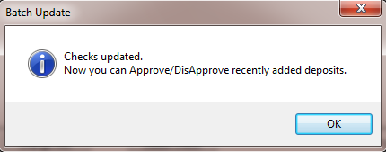
For most deposits, the regional office worker will be responsible for approving/disapproving a manual deposit. But if the manual deposit was made by central office to correct a deposit that went into a wrong account or to pay WARDS back for money paid to DCF in error, the central office worker will need to approve/disapprove the manual deposit.

B. Banking Processes
The WARDS accounts are held in a private banking institution, Capitol City Bank. There are multiple processes within WARDS that require interaction with the bank.

1. Batch Processes | Import Bank Statements
At least weekly, the WARDS Finance Manager will sign on to the bank website and download transactions processed by the bank since the last time a download was performed. This task can be done daily, if needed. See Appendix E of this manual for details on how to download bank transactions.
Once a file has been downloaded from the bank, it needs to be imported into WARDS.
Go to Batch Processes | Import Bank Statements. The screen that opens has you select the file you just downloaded from the bank saved on S:\Cfs.drw\GENERAL\Wards\In; then click <Import>.
Once the import is complete, click the button <Show Error> to be directed to the Bank Import Corrections screen (instructions next).

2. Transactions | Bank Import Corrections
After importing the bank export file (see Batch Process | Import Bank Statements), any transactions that could not be linked to a client will appear on this screen.
The main portion of this screen displays any errors. Select an error then click <Assign Client to Deposit> or <Mark as Bank Adjustment>.
- Assign Client to Deposit – If the client is not known to WARDS, you will need to add the client (see section for instruction on how to add a new client) before you can select them here.
- Mark as Bank Adjustment – Select this option if the error is not tied to a client (for instance, bank erroneously charged us a fee and this transaction is paying back that fee).

3. Batch Process | Distribute Interest
One of the transactions imported from the bank at the end of the month is a deposit of interest earned. WARDS distributes the interest to each account based on balances in each client’s account. This process should be performed the first week of each month, after the end of month transactions have been imported from the previous month.
Go to Batch Process | Distribute Interest. Select the Account Type.
If Regular account is selected, click <Start> to distribute interest.
If Dedicated or Non RD account is selected, type in the interest amount from the bank statement, then click <Start> to distribute interest.
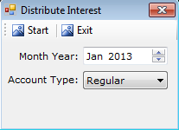
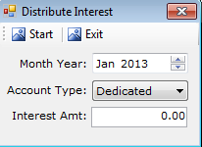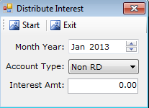

C. Reconciliation
Reconciling WARDS to the bank is an important process that ensures all bank transactions are matched to transactions in WARDS and that the balance in WARDS matches that in the bank. You’ll need an electronic copy of the bank statement, or a printout of the first page, for the month being reconciled.
NOTE: Waiting three weeks after the close of a month before performing these tasks will give the regions time to bring their clients’ accounts up to date.

1. Regular Account
There are two things to check prior to reconciling the regular account in WARDS: a) Make sure there are no pending deposits; and b) Make sure there are no unmatched deposits.
a) To ensure all deposits for the month being reconciled have been approved or disapproved, run the report, Report | Clients | Deposit Details. Select the “pending” filter to see only those deposits that still have a pending status. If no pending deposits exist for that month you are ready to proceed. If pending deposits exist, contact the regional supervisors requesting all deposits for that month be approved or disapproved.

b) Transactions | Reconciliation Corrections
Before reconciling a bank statement to WARDS, all unmatched deposits for that month from the bank imports (left side of screen) must be matched with corresponding unmatched entries in WARDS (right side of screen).
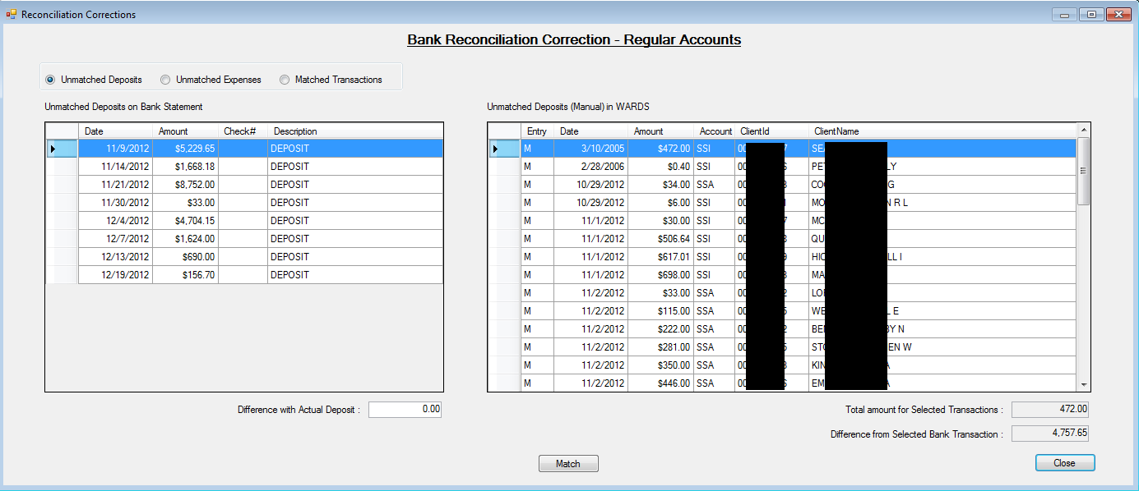

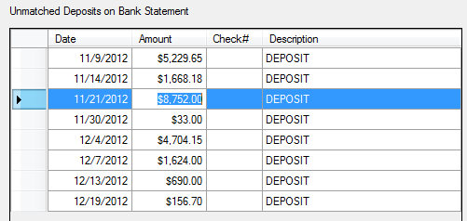
- Select the deposit on the left side of screen. Selecting the deposit will make the total of that deposit appear in the lower left corner…
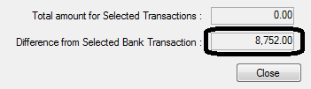

- Find the corresponding WARDS entries that make up that deposit from the right side of screen. Hold down the Ctrl button to select more than one WARDS entry.
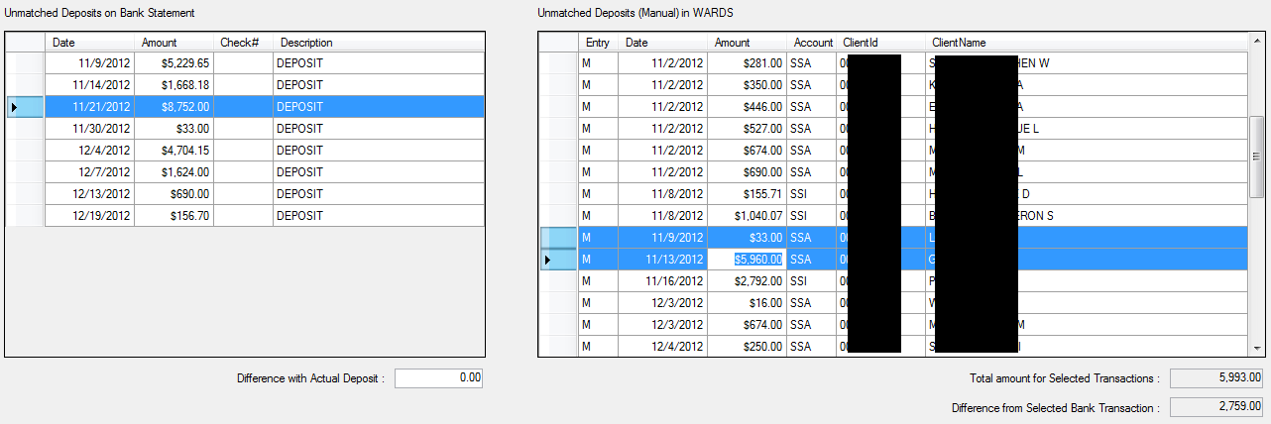
As entries on the right are selected, the Total Selected will increase in the lower right corner of the screen. Keep selecting entries until the total of the deposit is displayed. NOTE: Printing off copies of the manual deposits made that month before beginning this process will help you to find entries that match deposit totals.
- Once all entries are found, click <Match>.

c. Transactions | Bank Reconciliation-Regular Account
Reconciling the regular account is a two-step process. The first step involves the reconciliation report which ensures all transactions in the bank are matched to a corresponding transaction in WARDS. The second step makes sure the balance in the bank for the regular account matches the balance in WARDS.
Step 1 - Run the Reconciliation Report. Go to Transactions | Bank Reconciliation-Regular Account. Select the Month/Year you are reconciling; enter the Bank Opening Balance as it appears on the bank statement; click <Start>.
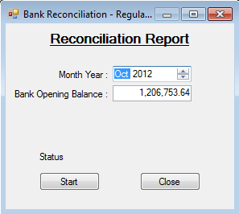
The resulting spreadsheet has a top portion and a bottom portion.

TOP PORTION: The left side is a summary of the bank statement, the right side is a summary of WARDS.
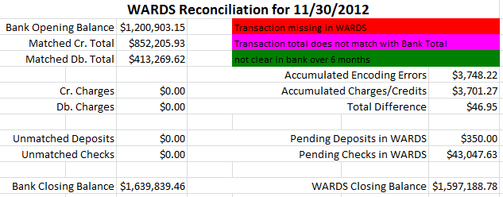
Things to look for…
- For the bank side (left side), all figures should match summary figures from the bank statement, i.e., Bank Closing Balance should match the “Ending balance” from the bank statement. If they do not, then corrections need to be made and the report reran until the numbers match.
- For the WARDS side (right side), any “Accumulated” errors or charges/credits need to be explained. See Confirmation Report explained in Appendix B.

BOTTOM PORTION: The first 4 columns (bankid, BankDate, ChkNo, and BankAmount) are taken from the bank imports. The other columns are taken from WARDS. Information from the bank has been matched to entries in WARDS.

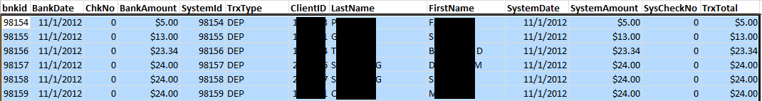
When you see blanks or zeros in the first 4 columns it means that the deposit or expense has not passed through the bank yet—it is an outstanding debit or credit. Example of outstanding checks…
Step 2 – Confirm that the WARDS Closing Balance on the Reconciliation Report matches the actual balance in WARDS. Use Tools | A/c Balance for a quick check of the account’s balance on the last day of the month being reconciled. If it matches the WARDS Closing Balance on the Reconciliation report, run a complete listing of balances including client details from Reports | Clients | Clients Balance Range: Select All Clients, Total Balance Between -100,000 and 100,000 (this ensures you get any clients with a negative balance in their account), and for “On Date”, enter the last day of the month being reconciled.
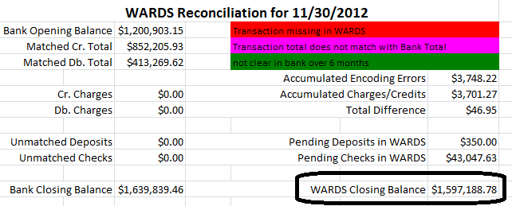
The WARDS Closing Balance on the Reconciliation report must match the total for the regular account on the Balance Range report. See example here.
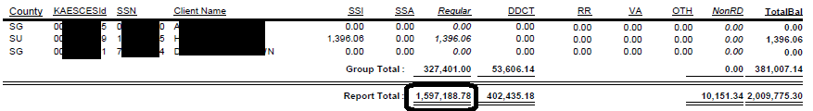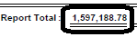
Troubleshooting discrepancies…

Problems on Bank side

- The bank side “Matched Cr. Total” does not match the Total additions on the bank statement or “Match Db. Total” does not match the Total subtractions on the bank statement.

Fix: Check the Reconciliation Correction screen to see if any deposits are unmatched for the month being reviewed.

- The “Bank Closing Balance” does not match the bank statement Ending balance.

Fix: Check the details on the Reconciliation Report; if any lines are highlighted in purple or red see WARDS Administrator to get cleaned up.

- The “Unmatched Deposits” contains an amount in red.

This means there are deposits still pending on the All Transaction screen of WARDS. Adding this figure to the “Matched Cr. Total” should equal the bank statement’s “Total additions”. It is preferable that there be no pending deposits before reconciling begins.

Problems on WARDS side

- The “Cr Charges” or “Db Charges” contains something other than -0- or has an amount you are not aware of.

Fix: Check the details on the Reconciliation report to see if something is in red or purple showing a (red) unmatched transaction to WARDS or (purple) a transaction that doesn’t match a total in WARDS. If the item is understood and accounted for, add it to the Reconciliation Confirmation report (see Appendix B for details regarding the Confirmation report).

- The bank ending balance matches the bank statement, but on the WARDS ending balance doesn’t match the balance range report.

Fix: Bring the discrepancy to the WARDS Administrator for further investigation.

Complete the Reconciliation Confirmation Report, explain further in Appendix B.

2. Dedicated and Non-RD Accounts
Reconciling the dedicated and non-RD accounts is handled differently from the regular account. There are still two steps, ensure all transactions are accounted for from the bank statement and the balance in WARDS matches the bank’s balance, but they are completed in one process. You’ll need a copy of the bank statement for the month being reconciled.
- Check that all deposits for the month being reconciled have been approved or disapproved by running the report, Report | Clients | Deposit Details. Select the “pending” filter to see only those deposits that still have a pending status. If no pending deposits exist for that month you are ready to reconcile. If pending deposits exist, contact the regional supervisors requesting all deposits for that month be approved or disapproved.
- Open Transactions | Bank Reconciliation-Non Regular Account. Select the following options:
Account Category: select Non RD or Dedicated
Month Year: Select the Month/Year being reconciled
Interest Applied: This will pre-fill with the interest applied to that month. If no amount appears the interest has not been applied yet. Ask WARDS Finance Manager to apply interest and then proceed.
Bank Ending Balance: Take ending balance from the bank statement. Click <Update Balance>.
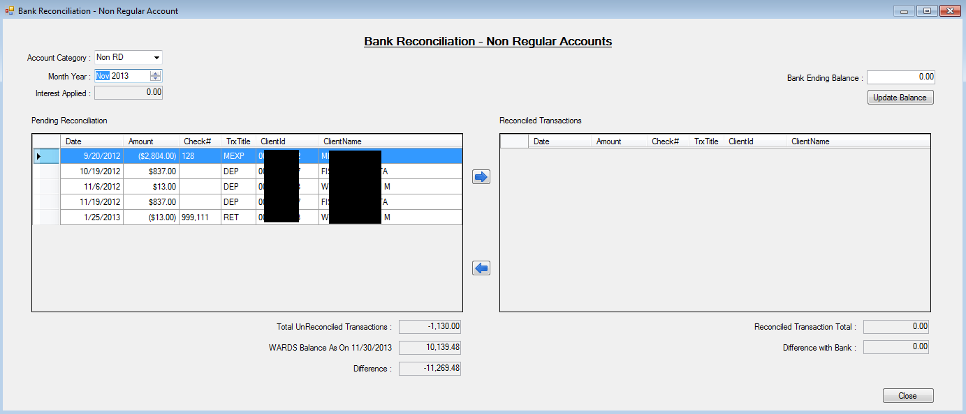

Look at the bank statement and make sure all the transactions on the bank statement have been moved to the right side of screen, Reconciled Transactions. To move a transaction from the left side to the right side, select the transaction at the left and click the arrow to move it to the right. As transactions are moved to the right, the Reconciled Transaction Total at the bottom right of the screen will change.

c) The balance in WARDS on the last day of the month being reconciled displays at the bottom of the screen along with a Difference. This difference must match the known difference documented on the Confirmation report. See Appendix B for more details regarding the reconciliation confirmation report for the non RD and dedicated accounts. If it does not match, contact the WARDS Administrator so the discrepancy can be resolved.

D. Reports | Finance
Following are the reports available from the Reports | Finance menu. When a report is listed a second time followed by the words “Excel Export”, it means the first listing should be selected when a printed, formatted report is desired; the second listing with “Excel Export” should be selected when the user needs the information saved in an Excel spreadsheet.

1. Bank Import Error List – When an import of bank transactions is done, any errors (transactions where the client could not be found) show up on a correction screen found under Transactions | Bank Import Corrections. Run this report if a listing of those errors is desired.
2. Interest Distribution – The Interest Distribution report shows balances in client accounts on a chosen EOM (end of month) date and the interest distributed to each client’s accounts.
3. Manual Deposits Details – Select a date range and the details of any manual deposits made during the period will display.
4. Manual Expenses Details – Select a date range and the details of any manual expenses made during the period will display.
5. Client Transaction Monthly Balance – This report shows a client’s Transaction Details in Service Month order rather than Transaction Month order. Social Security has dictated we apply a deposit in the month it was received (the Transaction Month), but we must pay a past month’s expense based on the balance in an account for that month (the Service Month). This report is primarily used by the the system administrator to ensure the system has calculated end-of-month balances correctly.
6. Print Checks – When a manual expense is completed, the user has the option to print the check then, from the Transactions | Manual Expenses screen, or run it later. It is through this report that users can print checks later. Select the account and the check number(s) and a copy of the check appears, ready to be printed.

7. Check Register – The check register report can be run for a specific period of time or for a span of check numbers. Transactions occurring in any account meeting the filter will appear on the report.

8. Checks Paid to CSS – NO LONGER USED.
Similar to the check register, the report can be run for a specific period of time or for a span of check numbers. All payments to CSE are made from the regular account.

9. Disapproved Amount Return to SSA –This report can be run for a specific period of time or for a span of check numbers.

10. Checks Paid for Expenses - This report can be run for a specific period of time or for a span of check numbers. It contains all checks written during filter specified.
The TrxType column identifies what type expense was made:
EXP = Encounter received from contractor of client’s cost of care
MEXP = Manual Expense; this could be an item purchased for the client or closing out a client’s account.

11. Interest Report (for 1099) – This report is requested once a year, usually in January, by Department of Administration. See Appendix C for file format description of report produced.

12. AFCARS Element 65 – This report is requested twice a year for the federal report AFCARS. See Appendix D for file format description of report produced.

E. Writing Checks

There are four reasons to write checks from a WARDS account:
- To return disapproved deposits to Social Security or other designee [processed through Batch Process | Return Disapproved Amounts to SSA];

- To pay Child Support for court ordered obligations paid from the parent’s disability benefit [processed through Batch Process | Process CSE Returns];

- To pay DCF for a child’s cost of care [processed through Batch Process | Process SRS Reimbursement];

- To process written requests from the regions to close out an account or make a special purchase for a client with their WARDS funds [processed through Transactions | Manual Expenses].

It is important to perform these options in the order presented because they follow a hierarchy: we cannot process a special request unless there’s money in the account to do so; we will not know if there’s money left in the account until we have reimbursed DCF for expenses; we will not know if there is money to reimburse DCF for expenses unless all disapproved money has been returned and CSE payments have been made.

When writing checks, perform all four processes in the order described below.

1. Batch Processes | Return Disapproved Amounts to SSA
When a deposit is disapproved or partially approved, the worker is forced to complete a screen explaining where the disapproved amount should be returned. That information is processed by central office through the Return Disapproved Amounts to SSA option.
Go to Batch Processes | Return Disapproved Amounts to SSA. Select an A/c Category: dedicated, nonRD, or regular. You will want to do this process for each account category. If no details appear in the window then there are no returns to make.
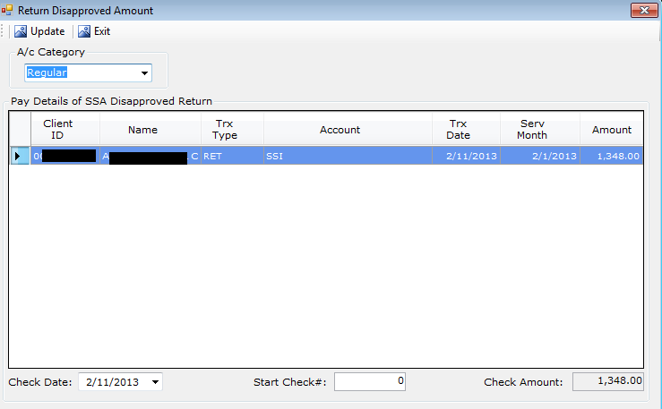
If details do appear, enter the next check number available, and click <Update>. One check will print for each return. A message will appear asking if you want to print checks now. Click <Yes>; put a stack of checks in the printer, starting with the check number entered on the screen, and print. NOTE: In the above example there is only one return. Multiple lines would show on the screen if there was more than one return.

2. Batch Processes | Process CSS Returns [Discontinued Dec 2014]
Child support court order information is entered on the Maintain | Clients screen.
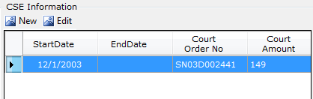
It is the information entered on this screen that allows WARDS to calculate child support money due to Child Support Services (CSS).
Go to Batch Processes | Process CSE Returns. If no details appear in the window then there are no payments to make; proceed to the next check writing step.
If details do appear, enter the next check number available from the regular account, and click <Update>. A message will appear asking if you want to print check now. Click <Yes> and the check will appear on the screen, ready for you to put the blank check in the printer so it can be printed.

3. Batch Process | Process DCF Reimbursement
Expenses, or encounters, are taken from SCRIPTS (Statewide Contractor Reimbursement, Information, and Payment Tracking System) and are automatically loaded into WARDS when a deposit is approved. The regional worker must then approve or disapprove the expense. Those expenses marked as approved are used to reimburse the agency for the client’s cost of care.
Go to Batch Process | Process SRS Reimbursement. Select an A/c Category; only non-RD and regular are accounts where reimbursement is sought. You will want to do this process for each account category. If no details appear in the window then there are no reimbursements to make.
If details do appear, enter the next check number available, and click <Update>. A message will appear asking if you want to print the check now. Click <Yes> to print it now.

4. Transactions | Manual Expenses
The Manual Expenses option is used when a check needs to be written from a WARDS account. Checks may need to be written to purchase something for a client (requests come from regional workers; see PPS PPM section 5929 for what is an allowable purchase), to send money back to Social Security or a new payee, or to move money erroneously deposited into the wrong account.
Initially, the screen is dimmed. Click <Select Client> and choose the client this expense is for. With the client selected, the other fields on the screen will become editable.
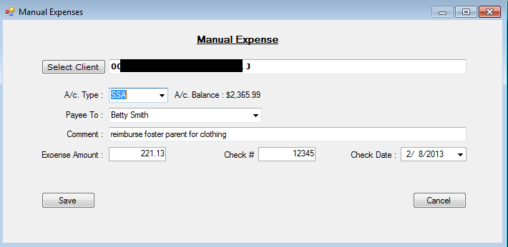
- Select account type: This is where the money is coming from. When the account is selected the balance in that account is displayed. You want to choose an account that has enough money in it to cover the expense.
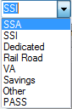
  - Regular Account=SSA or SSI or PASS.
“PASS” is explained in PPS PPM Section 5928.E.
  - Dedicated Account=Dedicated
  - non-RD= all others. “Savings” refers to money that does not fall into one of the other categories and should not be used to reimburse DCF for cost of care. See PPS PPM Section 5927 for an explanation of the other account types.
- Payee To: The pull-down menu allows the user to select a Social Security Office. If the payment is not to Social Security, type the name of the payee.
- Comment: Type the reason for the payment.
- Expense Amount: Enter amount check is to be written for.
- Check #: Write the next check # available.
- Check Date: defaults to today’s date.
- Click <Save>.
If there isn’t enough money in that account to cover the check the following message appears:
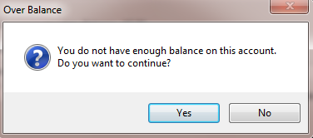
Select <No> to not continue so you can change the account type to one that has money to cover this expense.
- When the expense is successfully saved, a message appears asking if you want to print the check now.
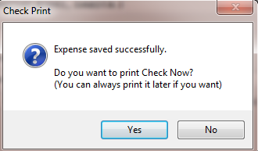

Select <Yes> if you want to print the check now; a screen opens with the layout of what will print on the check; proceed with printing. Select <No> if you want to print the check later. See Section V.D (Print Checks) of this manual for how to print the check later.

F. Voiding Checks
Use Transactions | Void Check option to void a check written by mistake or which has been returned uncashed.
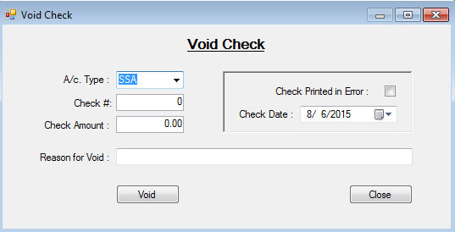
When check is outstanding more than 6 months, is lost, or has been returned and needs to be voided in WARDS:
- Select account type: Use the same account used when writing the check.
- Check #: Type in the check number.
- Check Amount: Type in the amount of the check.
- Write a brief explanation (limited to 50 characters) as to why the check needs voided.
- Click <Void>.
When a paper check was misprinted:
- Check the box “Check Printed in Error”
- Select the date this print error occurred
- Provide a reason for the void.
- Click <Void>.

Appendix A - BGInfo

BGInfo is in the status bar of your computer, lower right side. When you pass your mouse over this icon the words BGInfo appears. Click on the that icon to open it.
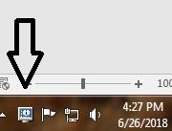

The screen that appears gives you information regarding your pc and its location.
The first entry on this screen is User Name. Your computer’s User Name should be used as the Login Name when setting up a new user in WARDS Maintain | Users screen.

Appendix B – Reconciliation Confirmation Report

The Reconciliation Confirmation Report (referred to as the Confirmation report) is a way to show that on the day reconciliation occurred, the balance in WARDS matched the bank—it confirms we reconciled.
These reports are saved on S:\Cfs.drw\GENERAL\Wards\Recon\Balance Confirmation Report. They contain a listing of discrepancies found in the system since its beginning in 2003, as well as any transactions to correct those discrepancies. For the regular account, these discrepancies are represented on the Reconciliation report under the labels “Accumulated Encoding Errors” and “Accumulated Charges/Credits”.
For the Regular Account
Once the Reconciliation Report and Balance Range report have been run and saved, you are ready to complete the Reconciliation Confirmation Report…
Step 1 – Create a new folder for the month
S:Cfs.drw\GENERAL\Wards\Recon\Balance Confirmation Reports\Regular\YYYYMM
Where YYYYMM = the year and month of the statement being reconciled
Step 2 – Copy Confirmation Report from last month
Open Confirmation report from previous month and save with new name in new folder created in Step 1.
Step 3 – New Screen Prints
Remove the screen print of the Reconciliation Report from the top portion of the report by selecting it and then hitting <Delete> on your keyboard. Do the same for the Balance Range report at the bottom of the page.
Put a new screen print from the Reconciliation Report completed for this month, and a new screen print of the Balance Range report. See box below regarding using the program Paint to accomplish this task.
Step 4 – New Titles
Change the title of the Confirmation Report to reflect the month being reconciled. Also change the date in the label for the Balance Range report at the bottom of the screen.
Following is an example of a completed Confirmation Report and what needs to match up.

Example of regular account Reconciliation Report:
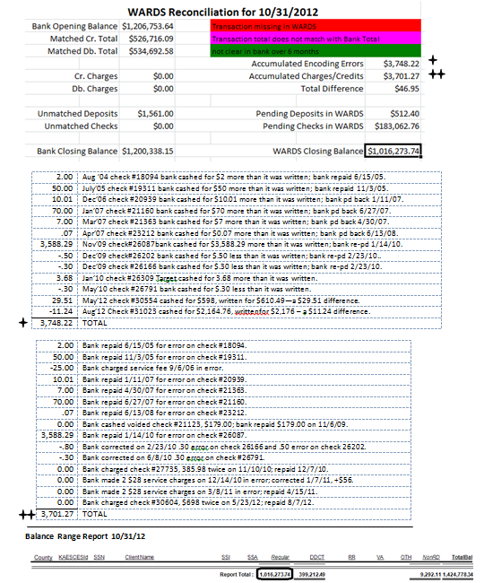

A copy of this final Confirmation report can be placed in the paper file held in the Finance department.

Using the Paint program to create a picture…
- Go to your Start menu , select All Programs | Accessories | Paint

- Open the Reconciliation Report. With the report showing on your screen, hit the “Print Screen” key.

- Bring the Paint program window back to the front. Click on Edit | Paste. The screen print you made of the Reconciliation Report will appear.

- Click the “Select” icon: . Click and drag a box around the summary section of the Reconciliation Report. Click on Edit | Copy .

- Open the Confirmation Report. Click on the line where you want the picture to appear. Right-click and select Paste.

Do the same with the Balance Range report, making a picture of only the last few lines of the report where you have added the sum.

For the Dedicated and Non-RD Accounts
A different Confirmation report exists for the Dedicated and Non-RD accounts.
Step 1 - Create a new folder for the month
S:Cfs.drw\GENERAL\Wards\Recon\Balance Confirmation Reports\[acct]\YYYYMM
Where [acct] = Non-RD or Dedicated
YYYYMM = the year and month of the statement being reconciled
Step 2 – Copy Confirmation Report from last month
Open Confirmation report from previous month and save with new name in new folder created in Step 1.
Step 3 – New Screen Prints
Remove the screen print of the Reconciliation Report by selecting it and then hitting <Delete> on your keyboard. Put a new screen print from the Reconciliation Report completed for this month. See box below regarding using the program Paint to accomplish this task.
Step 4 – New Titles
Change the title of the Confirmation Report to reflect the month being reconciled.

Following is an example of a completed Confirmation Report for the Non-RD account and what needs to match up.

Example of Non-RD account Reconciliation Confirmation Report…
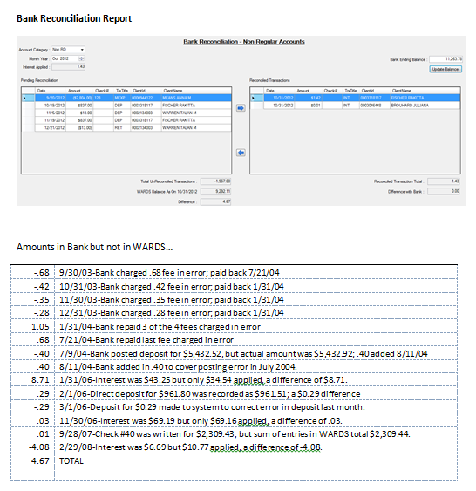

Appendix C – Technical Document – Interest Report for 1099
WARDS – Technical Document
Finance Reports | Interest Report (for 1099)

This report is submitted by the WARDS Finance Manager to Department of Administration in January of each year. Department of Administration prepares IRS Form 1099-INT from this report and sends the information to the IRS and to the individual clients in WARDS who earned interest of $10 or more for the previous year.

Check the box “Export for 1099 to MS Excel”. File is saved in Excel format. There are 2 street fields in FACTS. If “Street1” does not begin with a number then system will look at “Street2”; if “Street2” does not begin with a number then the default address/city/state/zip will be used. Any 1099 forms sent to the default address, or returned as undeliverable, will be sent to the WARDS Worker at the regional office.

 | Field Name | Field Length | Description
1 | VenType | 1 | Always use “2” (for SSN)
2 | VenNumber | 9 | Use client’s SSN from WARDS
3 | TypeCode | 1 | Always use “6 (for INT)
4 | Agency | 3 | Always use “629”
5 | Name | 40 | Take from WARDS; use all caps; FIRST NAME (space) MIDDLE INITIAL (space) LAST NAME
6 | Address | 40 | Take from FACTS (CFT_CFS_CLNT_ADDR) Street_1 or Street_2, whichever one has numbers included; use all caps; use the maximum SEQUENCE_NBR associated with the address.  Default: 915 SW HARRISON, AAO, 8TH FLOOR SOUTH
7 | City | 15 | Take from FACTS (CFT_CFS_CLNT_ADDR) City; use all caps  Default: TOPEKA
8 | State | 2 | Take from FACTS (CFT_CFS_CLNT_ADDR) State; use all caps  Default: KS
9 | Zip Code | 9 | Take from FACTS (CFT_CFS_CLNT_ADDR) Zip  Do not include hyphens; left justify if only 5 digits  Default: 666121570
10 | IntAmount | 12 | Take from WARDS – total interest for calendar year  no decimals (i.e. $3,312.48 would be recorded as 000000331248)
11 | Street1 |  | Take from FACTS (CFT_CFS_CLNT_ADDR)  THIS FIELD NEEDS TO BE DELETED PRIOR TO SENDING TO DofA.
12 | Street2 |  | Take from FACTS (CFT_CFS_CLNT_ADDR)  THIS FIELD NEEDS TO BE DELETED PRIOR TO SENDING TO DofA.

NOTE: “Street1” and “Street2” are added to the end of the spreadsheet so they can be reviewed before submitting file to Department of Administration (DofA). Before submitting file to DofA, do the following:
- Review any entries where the default address was used. Look at “Street1” and “Street2” to see if the default address is the best address to be used.
- Delete columns “Street1” and “Street2”.
- Save file.

Appendix D – Technical Document – AFCARS Element 65
1WARDS’ AFCARS Element #65
Element #65 of AFCARS requires that we report if the child is receiving support only from the State (indicated as a “0" in AFCARS Element 65) or from some other source (Federal or non-Federal) which is not indicated in elements #59 - #64 (indicated as a “1" in AFCARS Element 65).
#59 = received Title IV-E
#60 = received adoption subsidy
#61 = received IV-A (AFDC)
#62 = IV-D (child support)
#63 = Title XIX
#64 = SSI
 | Field Name | Size | Description
1 | Client ID | 10 | KAECSES/FACTS Client ID# (every child in WARDS will be listed regardless of whether their WARDS case is active or not)
2 | Date | 8 | YYYYMMDD, the first day of the month from the sample being reviewed. A child with no benefits in WARDS would have six lines in the text file (1 for each month of the review period), each showing -0- for the dollar amount received. A child with benefits in WARDS could have more than six lines in the text file if they received two different types of benefits in any given month (for example, both SSI and SSA).
3 | Amount | 5 | Total dollar amount of this benefit type (rounded up/down, no cents) for the month indicated above.
4 | Type | 5 | Type of benefit - used to reimburse SRS  SSI - Title XVI (16) Supplemental Security Income  SSA - Title II (2) Retirement, Survivors, & Disability Insurance  RR - Rail Road benefits  VA - Veteran benefits  Type of benefit - Conserved, NOT used to reimburse SRS  DDCT - SSI dedicated (large lump sum SSI deposits usually  conserved for the child)  SA - savings, conserved funds  OTH - any other funds needing conserved for the child

- A flat text file will be created;
- The file will be sorted by Client ID, then Date, then Type;
- It will be created upon request from ITS and/or the CFS-AFCARS coordinator twice a year: (1) for the period April-September; and (2) for the period October-March;
- Each month involved in the reporting period (April-September or October-March) will be considered for every child in WARDS each time the file is created based on data in WARDS on the day the file is created.
- If no benefit is received for given month, fields #3 & #4 are left blank; if a benefit is received, fields #3 & #4 contain the dollar amount and type; if a benefit was received but it was disapproved (returned to Social Security) an amount of -0- is listed for field #3.

Appendix E – Banking – How to Download Regular Account Transactions

Step 1 On Internet Explorer, open Capitol City Banks website… www.capcitybank.com

Step 2 In the heading, where Online Banking is displaying, change to <Cash Management>, click <Login>.

Step 3 Company ID: [contact WARDS administrator]
User ID: (your individual user ID) <Continue>.

Step 4 Type in the Password. <Sign On>

Step 5 Click the regular account, ending in 0164.
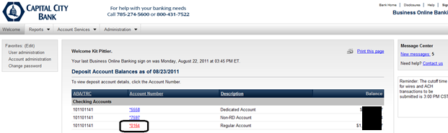

Step 6 Click “Account Activity Search”.
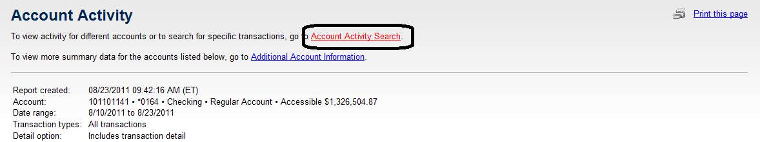

Step 7 The search screen appears.
Make sure the regular account is selected and enter the date range you desire.
Towards the bottom of the screen, click <Search>.
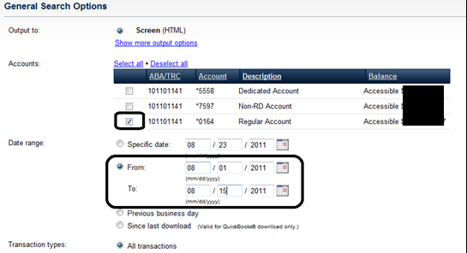

Step 8 All of the transactions for that time period will display.
Make sure the “Download this report as: CSV file” is selected. Click <Go>.
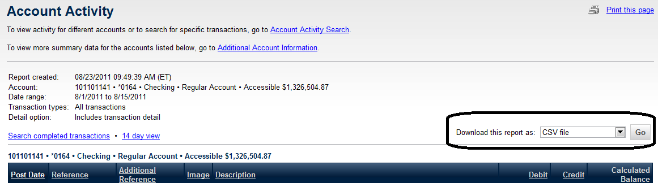

Step 9 The File Download dialog box appears. Click <Save>.
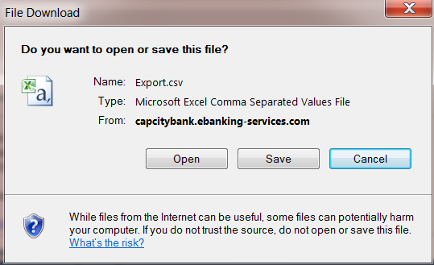

Step 10 Choose the following path to save the bank statement…
S:\Cfs.drw\GENERAL\WARDS\In\
Name the file as follows: CapssiMMMDD_YYYY_MMMDD_YYYY.csv
Example: CapssiAug01_2011_Aug15_2011.csv

Step 11 REPEAT Steps 6-11, once for the non-RD account and once for the dedicated account.

