



Volunteer Application
Become a Mentor
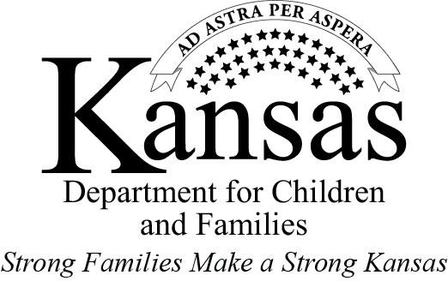

HOW TO APPLY
Please contact the Independent Living Coordinator (ILC) at your local Department for
Children and Families (DCF) office. The phone number is:

OR
If you already know a youth who needs a mentor, contact his or her Independent Living Coordinator and express your interest in becoming a mentor.

WHO ARE MENTORS?
Mentors are positive role models for youth who have been in the foster care system and are transitioning to self-sufficiency. Mentors are people who have a desire to assist youth to succeed by providing advice, counsel, and support. The likelihood of success for a youth who has been in the foster care system increases tremendously when the youth has a mentor in their life.
Everyone brings different strengths and talents to the table as a mentor. You may be a person who wants to forge a relationship with one youth, be a support to that youth and helping him or her to build self-sufficiency skills over time. Or you may have one or a few special talents where many youth could benefit from working with you on a more limited basis to build skills in your areas of expertise.
Youth aging out of foster care are often in a position where they can benefit greatly from support, education, and advice in every area of self-sufficiency. This includes areas such as; learning to take care of household tasks, budgeting, tax preparation or filing taxes, career preparation, job searches, how to buy a reliable car, cooking skills, resolving billing issues, learning how to make payment arrangements, building and maintaining positive peer relationships. If you have a desire to help, please know that there are youth that can benefit from your experience!
RESPONSIBILITIES
- Commitment to a minimum of 6 months for a youth
- Consult with the youth on details of the youth’s goals and progress towards those goals
- To participate in the youth’s self-sufficiency planning
- To document the meetings with the youth and providing this to the DCF ILC
- Advise the youth on budget, money management and learning how to maintain financial records
- Participate in training/educational activities regarding the roles of a mentor
- Assist the youth in the development and maintaining of employment skills
- Guide the youth in further development and enhancement of their life skills

QUALIFICATIONS
- Age 25 Or Older
- Ability To Pass A Kansas Bureau of Investigation (KBI) and
Child Abuse Neglect Central Registry Security Clearance
- Willingness To Work With Adolescents And Young Adults
- Knowledge Of Money Management
- Knowledge Of Skills Needed To Succeed In Daily Living
- DCF’s PPS Employees and Household Members of Employees Are Disqualified from Becoming Mentors.

WHAT DO YOU DO AS A MENTOR?
- Home for the holidays | - A place to do laundry
- Emergency place to stay | - Food/occasional meals
- Care packages for college | - Employment opportunities
- Job search assistance | - Career counseling
- Transportation | - Educational assistance
- Assistance with medical appointments | - Someone to talk to/discuss problems
- Chaperone | - Storage
- Motivation | - A phone to use
- A computer to use | - Clothing
- Spiritual support | - Help with obtaining legal assistance
- Cultural experiences | - Apartment move in
- Cooking sessions/assistance | - Regular check in (daily, weekly or monthly)
- Bills and money management assistance | - Help obtaining drug and alcohol addiction services
- Mechanical projects | - Building projects
- Housekeeping | - Home decorating
- Voting assistance | - Volunteerism
- Finding community resources | - Information about safety and personal security
- Help obtaining mental health support | - Babysitting
- Emergency cash | - Reference
- Advocacy | - Information about adoption
- Co-Signer  - Help with reading and understanding complex forms, documents | - Community activities  - Other activities as identified appropriate
The activities are typically determined by you and the youth; simple things like visiting a local fishing spot, providing a place to do laundry, teaching a hobby you enjoy, fixing them a meal or checking out a new movie are all perfect activities! As a mentor, you are filling a very important role. There are a wide variety of things that you may be able to do as a mentor, such as;

Mentor Application

NOTE: This form needs to be filled out before your consideration as a mentor; you must have security clearances due to the nature of your responsibilities.

First and Last Name | Birthdate | Date
Address | Home Phone Number | Work Phone Number
Mobile Number | E-Mail | Social Security Number

Name of youth you would like to mentor, if known.
Are you willing to help with a youth not previously known to you? |  |  |  | Yes | No
EDUCATION (Circle the highest year completed)
1 2 3 4 5 6 7 8 9 10 11 12 | College: 1 2 3 4 5 6
Vocational or Special Training
Present Occupation
Hobbies/Special Interests
Memberships (church, clubs, other
organizations)
Volunteer/Mentor experience
How did you hear about our mentoring
opportunity?
Why do you want to be a mentor?

Mentor Application Continued.
What are you willing to help with?
Refer to List on Page 3
If you are interested in mentoring in another area of the state, can we share your information
with other DCF and provider staff? |  |  |  |  |  |  |  |  |  |  |  |  |  |  |  |  | Yes |  |  |  | No
Can you speak a foreign language? |  |  |  |  |  |  |  |  |  |  |  |  |  |  |  |  | Yes |  |  |  | No
If yes please specify.
Willing to assist in transportation? |  |  |  |  |  |  |  |  |  |  |  |  |  |  |  |  | Yes |  |  |  | No
If yes, please provide current valid ID and Proof of auto insurance.

Driver’s license number: |  |  |  |  |  |  |  |  | Date issued: |  |  |  |  |  |  |  |  | State:
Auto Insurance Provider: |  |  |  |  |  |  |  |  |  |  |  | Policy Number:
References
Name: |  |  |  |  |  |  | Email/Phone#:
Name: |  |  |  |  |  |  | Email/Phone#:
Name: |  |  |  |  |  |  | Email/Phone#:
Emergency contact information
Name: |  |  |  |  |  |  | Address:
Relationship: |  |  |  |  |  |  | Phone Number:
Additional comments and/or questions.
Printed Name: |  |  |  |  |  |  |  |  |  | Signature:
Date:
*Please submit the completed Mentor Application to your local ILC’s DCF office.

DCF Staff Only

Region To Be Considered | Approved: Yes No
Location To Be Considered | DCF IL Staff Signature Date
 | DCF IL Supervisor Initials

PLEASE PRINT CLEARLY
Reason for Request: Check One
 | Employment |  | Home Study |  | ICPC
 | CWEP |  | Volunteer |  | JTPA
XX  Security Clearance Request Form | Other: Explain | IL Mentor

Caregiver Position? |  | Yes | XX | No

FBI Check?  (Attach Fingerprints) | ______ Yes XX No
Last Name
Include suffix (Jr., SR., etc.) if any.)
First Name
Middle Name
Maiden Name
Other Names
Address 1
Address 2
Phone

Gender |  | Race
SSN |  | Birth Date

Driver’s License
State of Issuance

Return results to:
Name
Office or Institution | Department for Children and Families
E-Mail Address
PCA Number
Search Results |  | Fingerprints Sent?

FBI  KBI | ___ | No Record  No Record | _____ | See Attached  See Attached
Compact-DOC Supv. |  | No Record |  | See Attached
Adult Abuse Registry |  | No Record |  | Record
Child Abuse Registry |  | No Record |  | Record

Date Signature

Welfare Fraud Finding |  | No Record |  | Record

Date Signature
Appointing Authority Decision:
 | Clearance Granted |  | Clearance Denied

Signature of Appointing Authority Date

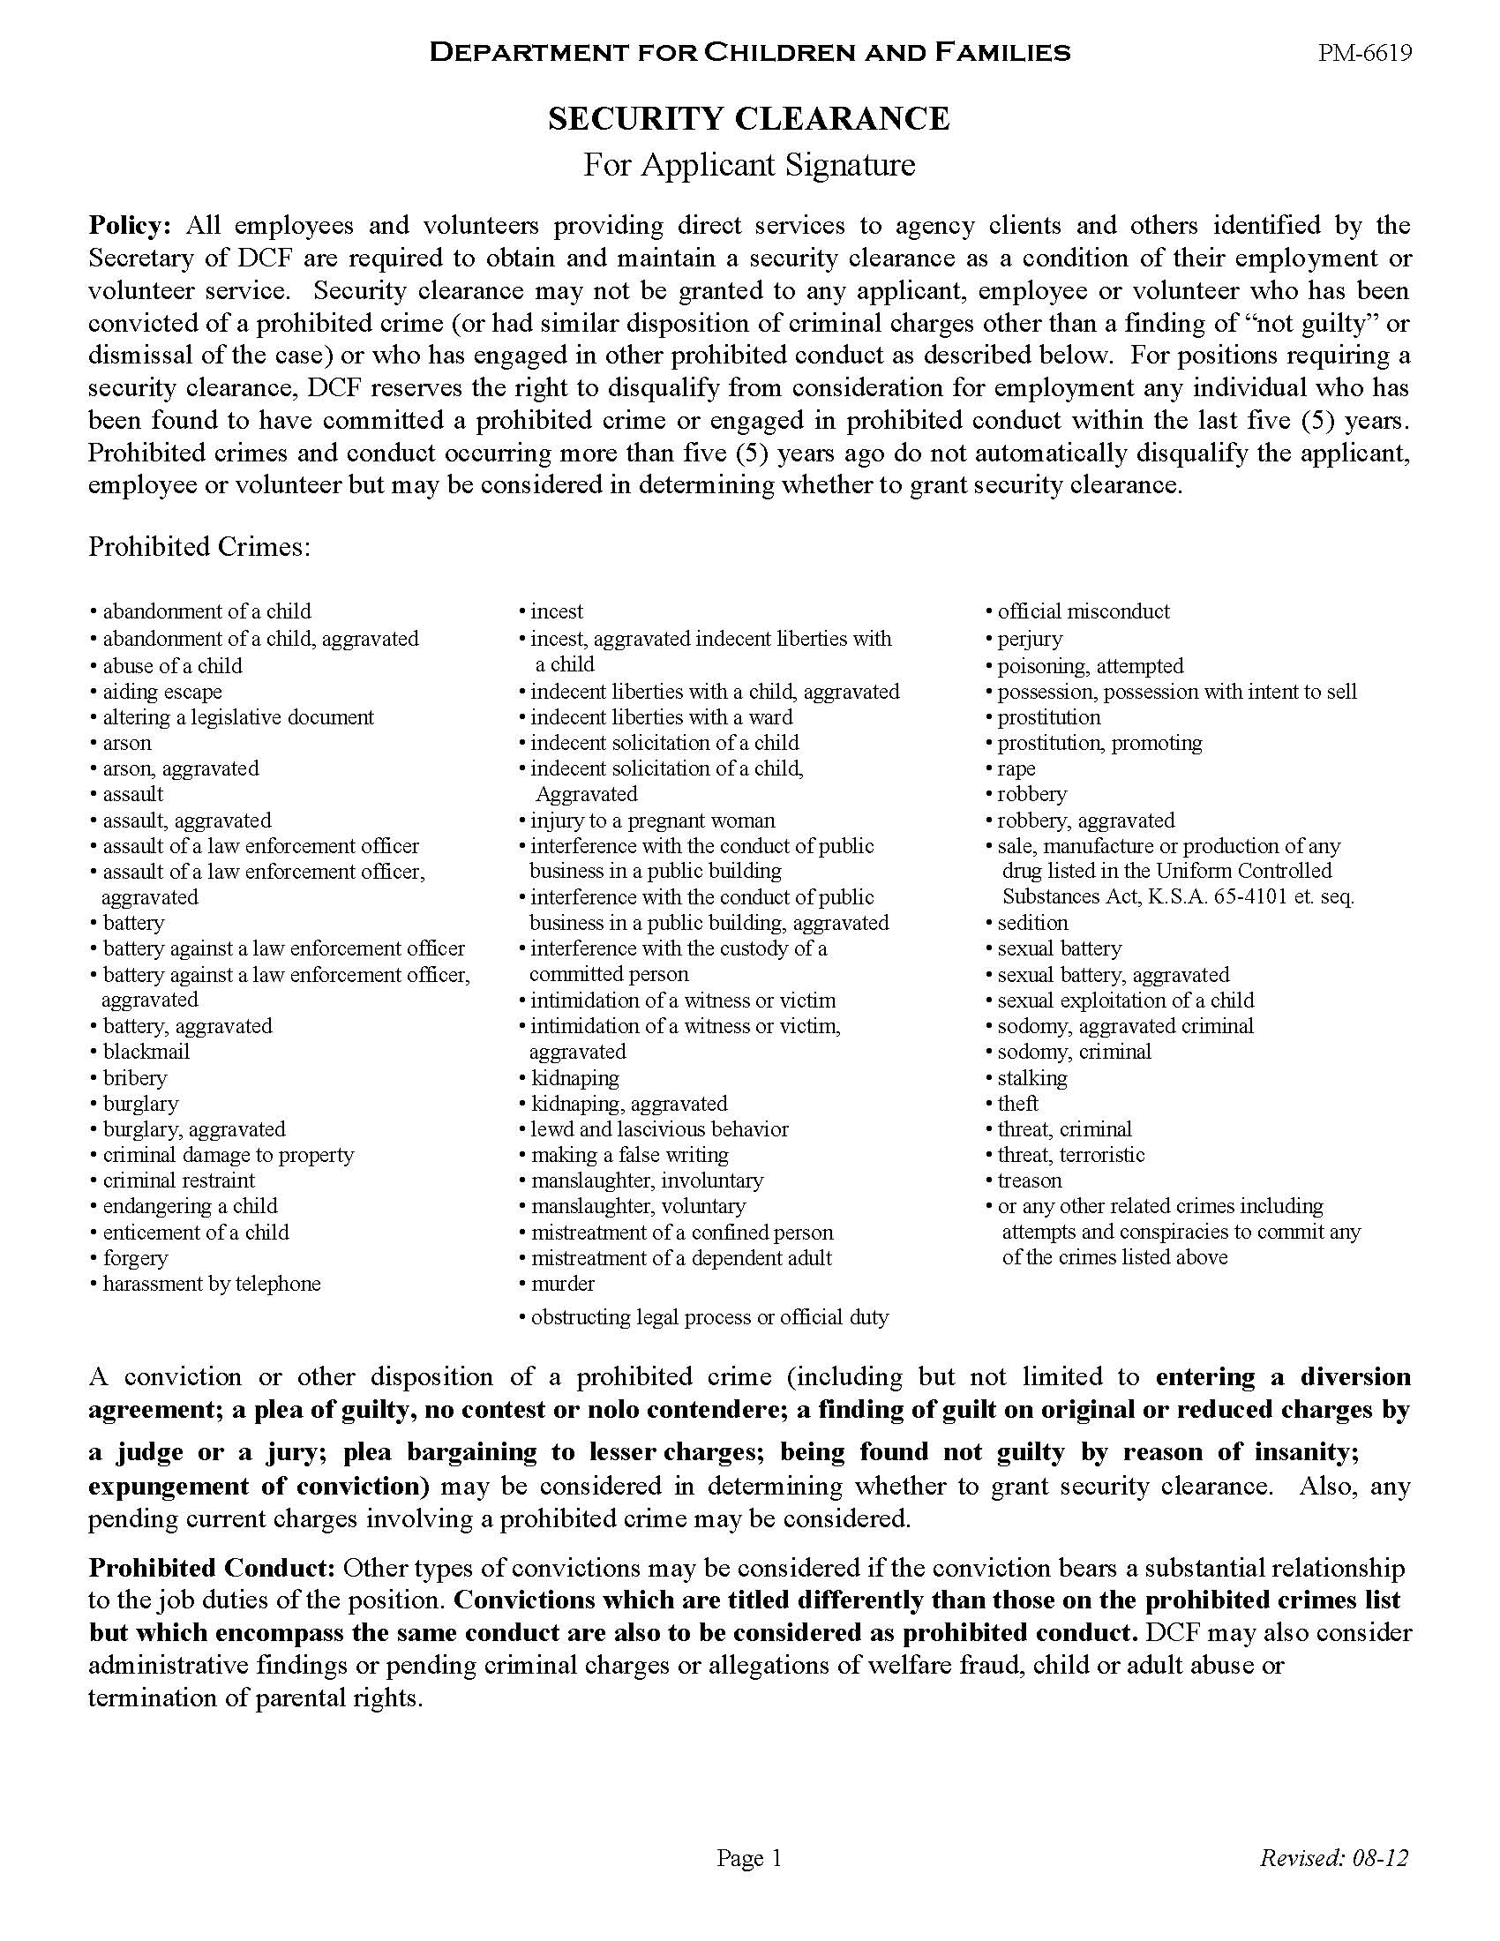

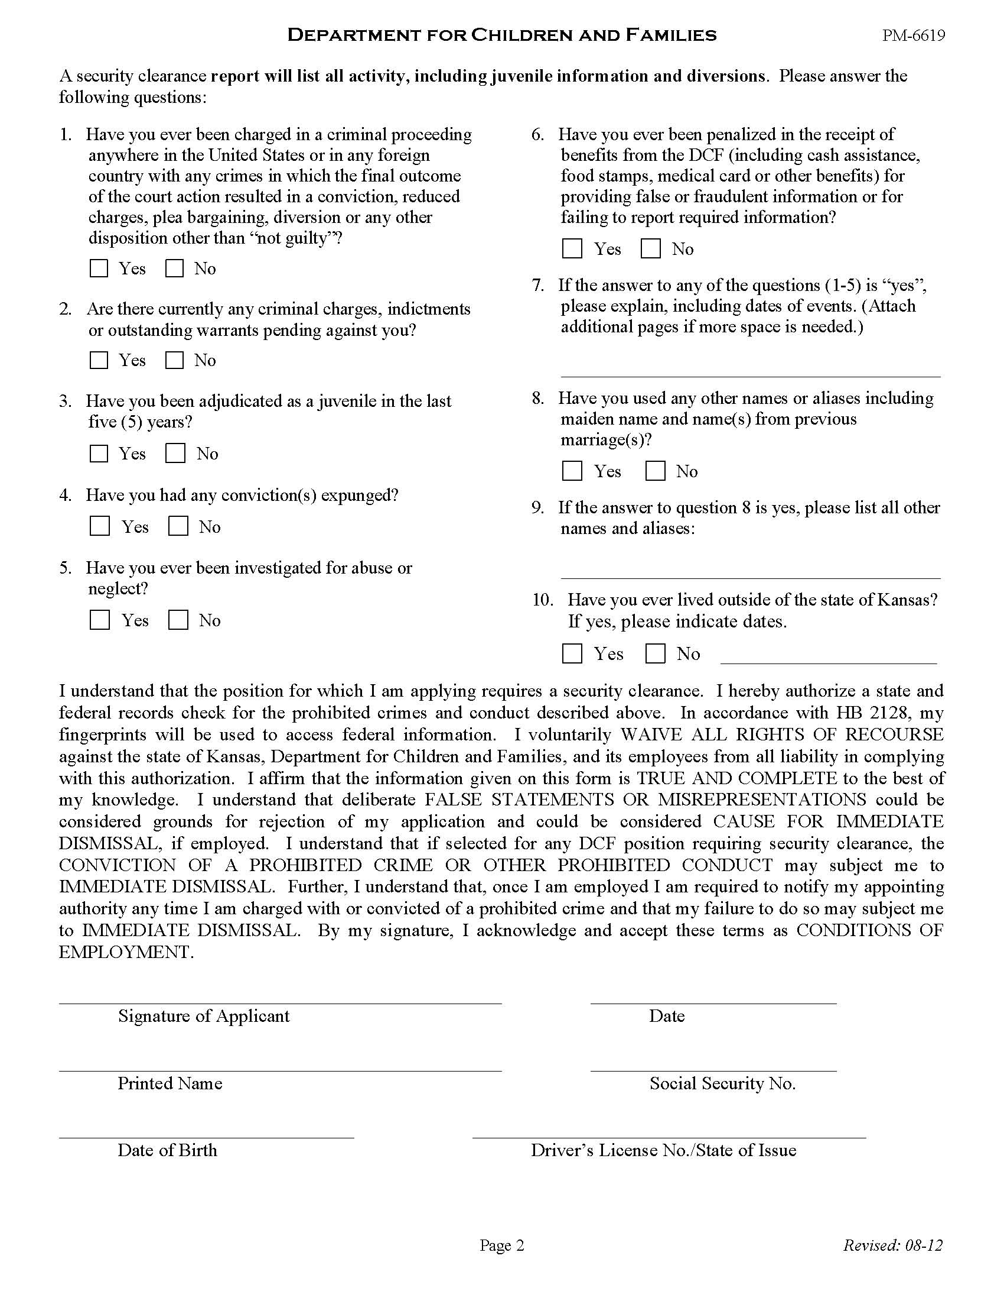
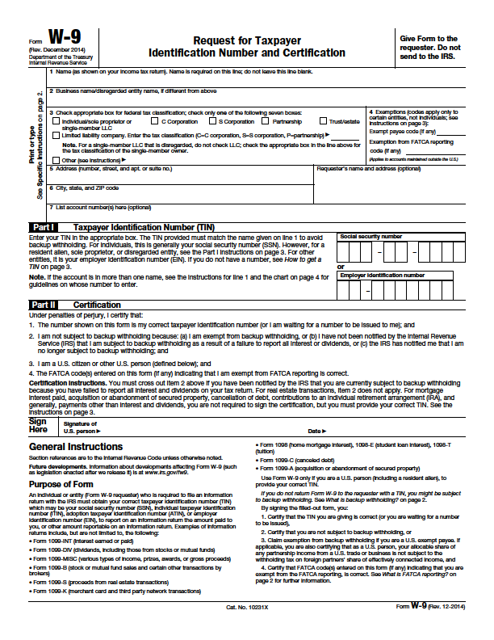
INDEPENDENT LIVING MENTOR AGREEMENT
PPS 7220 EXAMPLE

I, (mentor printed name), agree that:
- I will be committing myself to a six-month term as a Mentor for __________________________________ (name of young adult), a young adult working toward self-sufficiency.

- My term of service to this young adult will begin on ___________________ (date) and end on ____________________ (date).

- I will complete a Mentor Application initially, which will be maintained in a separate mentor file in the Regional Independent Living Program office. I agree to notify the DCF Independent Living Coordinator (ILC) of any information changes on the Mentor Application.

- I hereby give my consent to screening through background checks and law enforcement records of the State of Kansas Registry for Child Abuse and Neglect and Kansas Bureau of Investigation. The results of all security checks will be maintained, confidentially, in the mentor file.

- I will receive a copy of the young adult’s Independent Living Subsidy Payment Unit Notification PPS 7210.

- I may, contingent upon the young adult’s situation, receive the Subsidy payment for the young adult, each month and assist the young adult in utilizing these funds for the purpose of making monthly payments toward appropriate bills or financial commitments.

- I will advise the young adult in money management and assist the young adult in maintaining a monthly budget and financial records of bills and payments. I will provide r the DCF ILC with copies of these records upon request.

- I will meet with the young adult whom I serve as stated in the Self-Sufficiency Plan PPS 7000 and will document my contacts with the young adult on the Independent Living Monthly Mentor Report PPS 7215. I will provide the DCF ILC with the completed Mentor Report each month.

- I will monitor the young adult’s school and/or work attendance and performance.

- Any information known about the young adult is confidential and I am not allowed to discuss the information with anyone other than the DCF ILC, DCF social worker or designated staff person. Violation of the young adult’s confidentiality is grounds for termination of the mentor / mentee relationship. I understand that violation of consumer confidentiality as described will be subject to DCF, State, and Federal regulation.

- Young adults are entitled to access most information contained in their case records at any time. I will not write anything in a record that I don’t want the young adult to see.

- In this volunteer capacity for the agency, I will not be covered for personal injury or personal liability through the Kansas Department for Children and Families.

- As a mentor for a young adult, I may receive a $50.00 monthly stipend to assist with incurred expenses, contingent upon available DCF Regional funds. Mentor stipends are considered reportable income. To receive the stipend, I will have completed the W-9 Request for Taxpayer Identification Number and Certification, which will be maintained in the mentor file. I will notify the DCF ILC or designated staff of any changes in my address or name. Failure to submit the Independent Living Monthly Mentor Report PPS 7215 will result in monthly stipend suspension.

I have read and do hereby state that I understand each of these statements. I hereby agree to comply with this statement as written.

SIGNATURE OF MENTOR: |  | DATE:
SIGNATURE OF ILC: |  | DATE:



