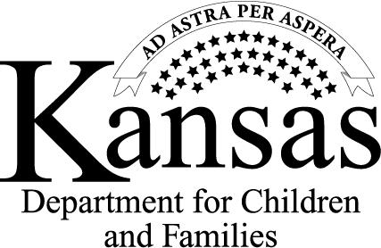
Jeff Colyer, Governor
Regional Letter head

Gina Meier-Hummel, Secretary

January 8, 2013
Annual Adoption Assistance Review
Second Notice

Adoptive Parents Address

RE: Child Information

Dear

Thirty days or more have passed since we sent you an annual review form to complete regarding your adoption assistance case with DCF.

We have not received your completed review and hope we have not lost contact with you. It is very important you return the completed review. When a review is not received, procedures must be initiated to determine if the adoptive parents continue to have legal or financial responsibility for the child. Your case may be closed or the benefits you receive through your adoption assistance agreement suspended if we do not receive the completed review form and we determine that you are no longer legally or financially responsible for the above mentioned child(ren).

Please help us maintain contact with you by returning the completed review form along with the required documentation by (enter date). Another review form is enclosed for you convenience. Please return the completed review in the enclosed postage paid envelope.

If you have questions regarding the annual Adoption Assistance review or the Adoption Assistance you currently receive, please contact .

Sincerely,

