About Prevention and Protection Services

Mission: Prevention, protection and preservation in child’s time.
Vision: All children are safe in nurturing families and communities.

Case Manager Contact

Case Manager Name

Phone

Email

Permanent Custodianship Subsidy


A program to help achieve permanency for youth.

Kansas Department for Children and Families Prevention and Protection Services
555 S. Kansas Ave., 4th floor Topeka, Ks. 66603
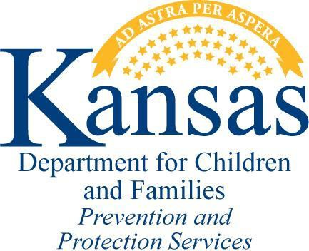

Permanent Custodianship Subsidy

In 1999, the Legislature set up funding for a subsidy program to assist families who want to be permanent guardians for children in DCF custody.

In 2007, the Child in Need of Care (CINC) Code changed the term for this arrangement to custodian.

Establishment of Custodianship
Custodianship / Guardianship can be established through a Child in Need of Care case or through Probate Court.

In order to be considered a permanent custodian, the custodianship must be established through a CINC case.

Eligibility
- Child must be in DCF custody and out of home placement at the time custodianship is established.
- Children may be considered for permanent custodianship subsidy if he/she is age 14 and over, or are part of a sibling group being placed together and one child is age 14 and over, or have an approval for an exception from the PPS Director for other extenuating circumstances that make adoption not a reasonable option.
- An order of permanent custodianship must be issued by the court.
- Child may not be receiving Supplemental Security Income (SSI).
- An appointed custodian must be an adult eligible to receive Temporary Assistance to Needy Families (TANF) as defined by Economic and Employment Support Services.
- The custodian is encouraged to apply for TANF on behalf of the child.

Amount of Subsidy Monthly Maximum Subsidy: $300
May be lower based on the income and resources of the child.

Income and resources considered
- Social Security Survivors Benefits
- Child support
- Income for the child from a trust or annuity
- Other benefits such as railroad retirement and veterans benefits

Income and resources not considered
- Earned income of the child
- Resources of the child
- Inaccessible trusts of the child
- Income and resources of the custodian and spouse
- Income and resources of the parent
- TANF benefits received for the child

Children cannot receive subsidy if their countable income exceeds $300/month.

The amount of benefits will affect the amount of subsidy and the TANF payment.

Custodians are expected to apply to be the payee for benefits on behalf of the child. If parental rights are not terminated, the parents will need to agree that the custodian can be the payee.

Amount of Subsidy Continued
Once the subsidy amount is established, it does not change unless there is a change in the child’s circumstances such as:
- Custodianship is set aside,
- Custodian ceases to be legally or financially responsible for the child,
- Child reaches 18 and has completed high school,
- Child becomes emancipated,
- Child dies.
In the event that any of these changes occur, the custodian must notify DCF immediately.

Annual Review

Custodians must cooperate fully in the completion of an annual review. Failure to return the annual review will result in closure of the case.

Medical Coverage

The child will continue to receive a medical card as long as they are getting a custodianship subsidy, but the parent’s family health insurance will be used if parental rights are not terminated. If possible, the custodian is expected to include the child on their family medical insurance plan. Kansas medical cards can only be used with Kansas Medicaid Providers.

Funding for the Subsidy
The custodian subsidy is supported by State money, therefore, limited funds are available.

