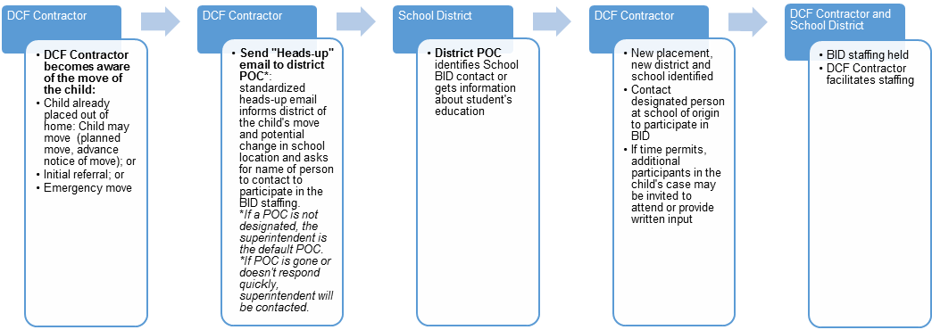
Educational Stability Process Map

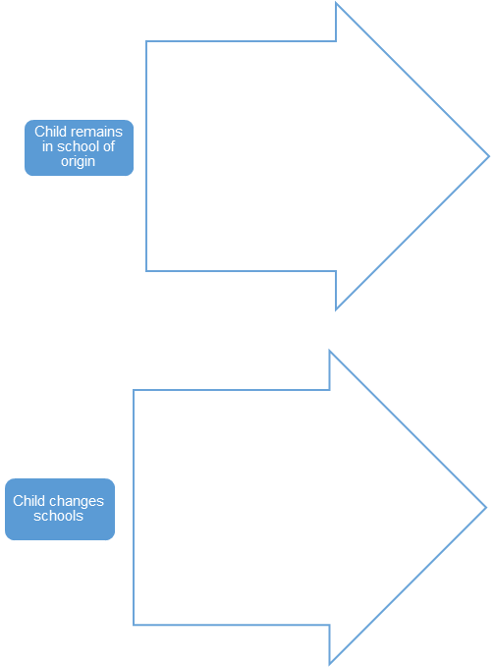
OR
- DCF Contractor update PPS 5254
- Discuss transportation at the BID staffing, if possible.
  - If negotiation is needed, refer to DCF Contractor designee and LEA Superintendent.
- DCF Contractor and LEA Identify
  - Source of transportation
  - Possible funding sources
  - Plan for payment

- DCF Contractor sends updated PPS5254 to receiving school
- Receiving school
  - enrolls child immediately
  - requests records from sending school
- Sending school should send records to the receiving school within 1-3 business days (if emergent: Sending school should transfer records w/in 24 hours)

BID = Best Interest Determination. The presumption is that a child will stay in their school of origin unless it is determined to be in their best interest to change schools. The BID shall be based on all factors relating to the child’s best interest, including consideration of the appropriateness of the current educational setting and the proximity to the school in which the child is enrolled at the time of placement. Though the final decision in the best interest determination rests with DCF or their contractor, this is the LEA’s opportunity to participate in the process. Ideally, the BID would include, at a minimum, the DCF Contractor and the POC. However, due to time constraints involved in changing the placement of a child, if the POC fails to respond in a timely manner, the DCF Contractor may need to make the best interest determination with the most current information they have.
Factors to consider in the BID include (information the school may have in blue):
- Child preference
- Child safety
- Parent preference, if parental rights are intact
- Child’s attachment to the school
- Placement of siblings
- Influence of school climate
- Availability and Quality of Services
- Transportation considerations*
- IEP and 504 plan services
- EL Language services

*Transportation considerations:
- Duration of the transportation
- Age of child
- Time of placement change (Is it Day 30 or Day 160 of school year?)
- Type of transportation available
- Traffic pattern
- Flexibility in school schedule
- Impact of extracurricular activities on transportation options
- Maturity and behavioral capacity of child
- If the child has an IEP – FAPE funds may be available for transportation

Best Interest Determination Staffing (BID)
The BID staffing should include the LEA POC and DCF Contractor, at a minimum. Additional participants with relevant knowledge of the child’s situation may be invited to attend the staffing or provide written input for consideration. Additional participants may include:
  - Biological Parents, if parental rights are intact
  - Foster Parents
  - Guardian Ad Litem
  - Educational Advocate
  - DCF Staff
  - Court Appointed Special Advocate (CASA)

DCF Contractor = an employee of either KVC Kansas (KVC) or Saint Francis Community Services (SFCS)
POC = point of contact, the person LEA designates for communication about children in foster care and is knowledgeable about district resources if transportation needs to be negotiated; POC could refer KVC/SFCS to a school contact who is more knowledgeable about the student’s education for the BID as appropriate or gather the information internally and participate in the BID
SEA = State Education Agency, the Kansas State Department of Education
School contact = POC can assign a school contact to participate in the BID when the school contact has information related to the child.
LEA = Local Education Agency. This usually refers to the school district
A & P = DCF Assessment and Prevention Investigator/Supervisor
IEP = Individualized Education Program, for when the child needs special education
FAPE = Free Appropriate Public Education; an educational right of children with disabilities, may be able to provide funding for transportation for children with an IEP



