Male | Ο  Female | Transgender (Female to Male) | Transgender (Male to Female)  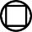 | Non-Binary
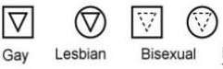 | 6-19-41 to  Birthdate is indicated above and left of symbol | 5-25-27  Date of death is indicated above and right of symbol | 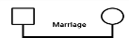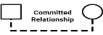 | 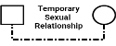
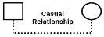 | 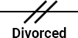 | 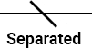 | 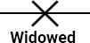 | 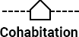
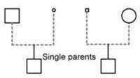 |  | 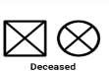 | 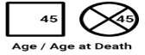 | 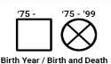

abortion miscarriage stillbirth child
twins
⏐
Ø
⏐
°
⏐
x
⏐
Δ
pregnancy
child
¦ ⏐¦
Ο Ο
foster adopted
/\
- Ο
twins child
⏐ /\
- Ο─O
biological identical
⏐ ⏐
Mother

Father
Ο
Children: list in birth order beginning with the oldest on the left

SYMBOLS DENOTING INTERACTIONAL PATTERNS BETWEEN PEOPLE

- Ο  close  ——>  focused on | Ο……Ο  distant  Ο┤├─Ο  cut off | Οvvvv  hostile  Οvvv►  sexual abuse | ≡≡≡≡  fused  vvvvv▶Ο  physical abuse

