The KIDS system has an upload feature that allows staff to upload, view or delete a document. Users who have access to update a case will have the ability to upload, view or delete a document in KIDS by clicking on the “Add Attachment” or “View Attachment” button on the Assessment Tools page.

Details:

- The most common types of documents that users would attach to a case will be .pdf, gif, .doc, docx, .tif, .png, .jpg, .txt, .xls or .xlsx extensions

- E-mails with attachments can be added to a case

- Documents must be smaller than 2 gigabytes in size

- Documents with .exe extensions should not be uploaded

- Zip files should not be uploaded

Instructions: To upload a document, click the “Add Attachment” button. A browser window, titled CIFA - Case File Attachment will open allowing the user to search for a document to be added to the case. When the document is found, highlight the document and click the “Open” button in the browser window. The file location and name will display in the browser window in KIDS. If the correct file has been selected, click the button labeled “Save”. A message will display at the top of the window indicating the selected document has been saved. If the wrong file has been selected to save, just click the close button without saving and repeat the process to add the correct document.

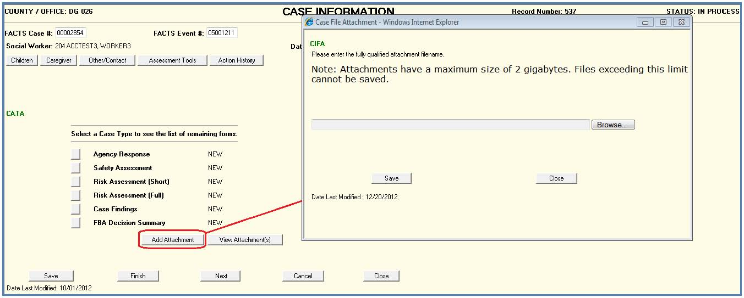

View Attachment(s)
To view documents that have been saved, click the “View Attachment(s)” button on the Assessment Tool Page. The CIFV - Case File Attachment View window will display with a listing of all documents attached to the case. Highlight the document to be viewed and click the “View” button.

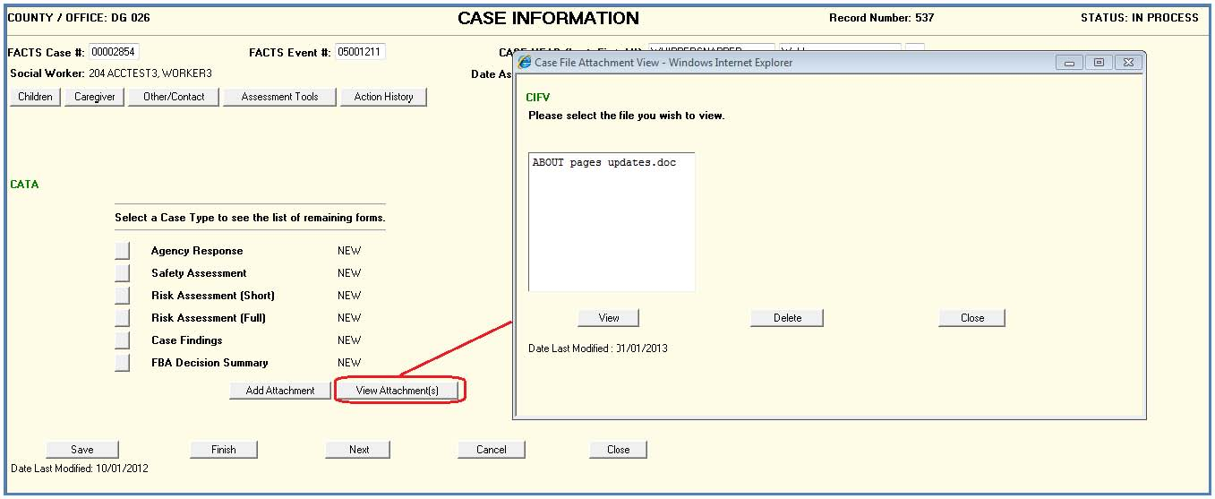

Delete Attachment
To remove an attached document from a case, access the Assessment tool page, click the “View Attachment(s)” button. When the list of documents displays, select the file to be deleted and click the “Delete” button. When the user confirms the delete action, the document will no longer be attached to the case.

Restrictions:

- If a document name needs to be changed, it should be changed before uploading into KIDS as there is no renaming functionality in KIDs.

- The upload function is not available if a case has been accessed in „View‟ mode.

- If a user does not have Add or Edit capability in KIDS the „Add Attachment‟ button and „Delete‟ buttons will not display on the appropriate page.

- If a case is in Finished Status, documents can be viewed, but not added or deleted.

