How to Protect Yourself from Becoming a Victim
How to Report Suspected Abuse

- Don’t sign blank checks allowing
another person to fill in the amount.
- Don’t leave money or valuables in plain view.
- Be aware of scams (either by phone or through the mail). If it sounds too good to be true, it probably is.
- Don’t give strangers access
to your bank accounts.
- Check your financial statements frequently and carefully for unauthorized withdrawals.
- Don’t sign any document you have not completely read or fully understood.
- Don’t be pressured by family members, friends, caregivers, or anyone else to do anything you don’t want to do.
- Don’t sign over property deeds, titles, etc. without legal review.
If you suspect a person who is vulnerable, elderly, or disabled is being financially exploited, call the Kansas Department for Children and Families
Abuse and Neglect hotline.

Kansas Protection Report Center
1-800-922-5330

Law Enforcement is notified when a suspected crime has been committed.

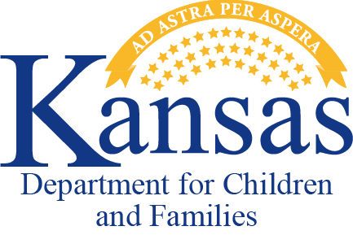
Financial Exploitation
If it’s not your money, taking it is a crime.

Kansas Department for Children and Families Adult Protective Services
www.dcf.ks.gov
PPS-10050 REV 02/22

This project was supported by a grant under the Older Americans Act from the U.S . Administration on Aging, Administration for Community Living, Dept.
of Health and Human Services , in partnership with Kansas Dept. for Aging and Disability Services.

What is Financial Exploitation? Who Might be an Abuser? Potential Signs of Financial

Financial exploitation is the illegal or improper use of another person’s money or property for personal profit or gain. Financial exploitation of adults who are vulnerable, elderly or disabled
is an increasing problem and protecting them from becoming victims is everyone’s business.

Examples of Financial Exploitation
- cashing checks without authorization or permission
- misusing or stealing a person’s
money or possessions
- coercing or deceiving a person into signing
documents such as a contract or will
- improper use of conservatorship, guardianship, or power of attorney

family members
- caregivers - paid or volunteer
- strangers - met in public or those who come to the home
- professionals hired by or appointed for the victim, such as accountants or lawyers

guardians
- agents with durable power of attorney or anyone you authorize to act on your behalf

Potential Signs of Financial Exploitation
- changing account beneficiaries
- sudden unexplained changes in bank
accounts or banking practices
- unexplained withdrawal of money by a person accompanying the account holder
- adding additional names to bank
accounts or signature cards

unapproved withdrawal of
funds using an ATM card
- new applications for credit cards or banking cards
- out of sequence check numbers
- redirected mail

Exploitation Continued
- sudden changes in a will, property title, deeds or other financial documents
- unexplained missing funds or valuables
- providing substandard care
- unpaid bills despite having enough money
- forged signature for financial transaction or for the titles of the property
- appearance of uninvolved relatives suddenly becoming the person’s representative
- unexplained sudden transfer of assets
- providing unnecessary services
- a complaint of financial exploitation

