Kansas Electronic Adult & Child Registry Process Guide

Who Is Allowed to fill out the online form?
- General public filling it out for themselves
- Agencies that have a DCF Signed Release on File for Audit Purposes
Portal Log In Page:
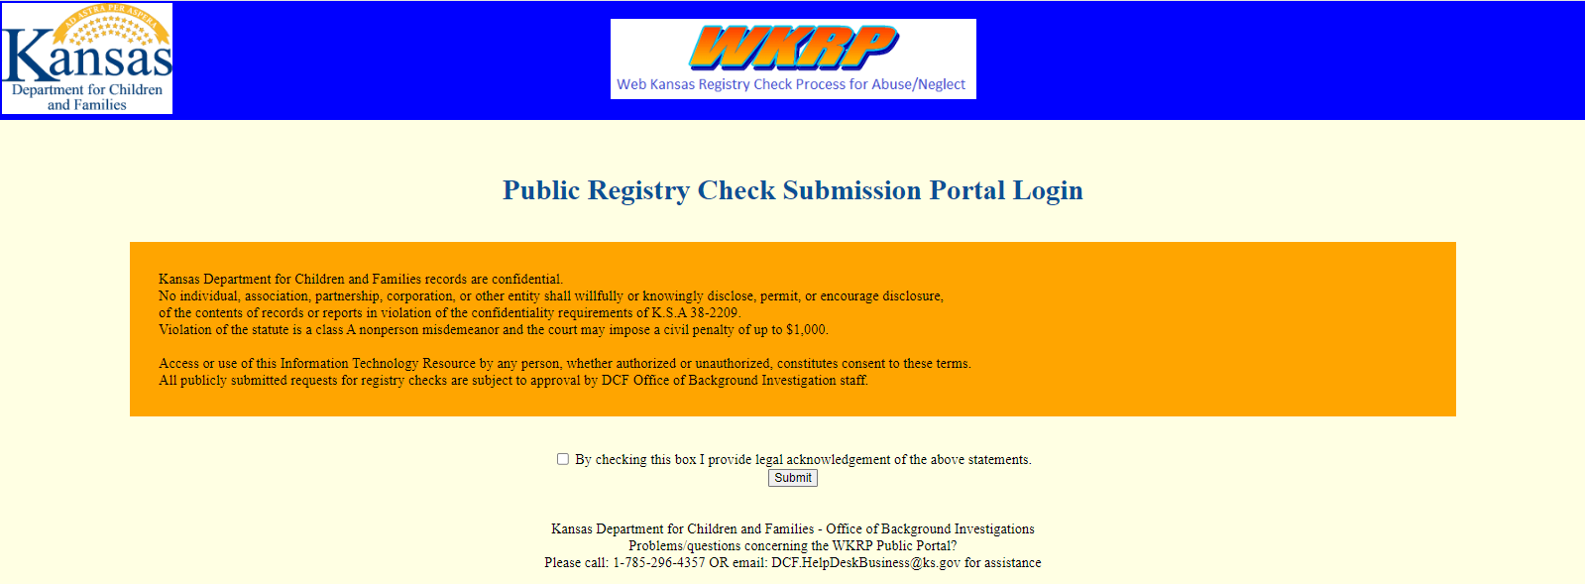

Registry Selection Page:
- May select One or Both Registries
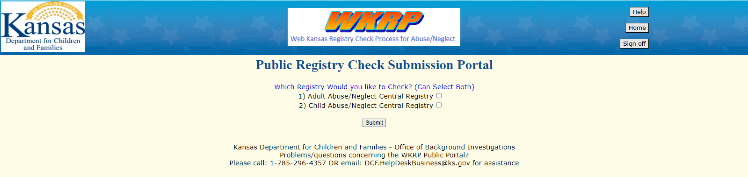
Payment Page if the Child Registry is selected:
- Adult Registry is Free
- Child Registry is $10/Each
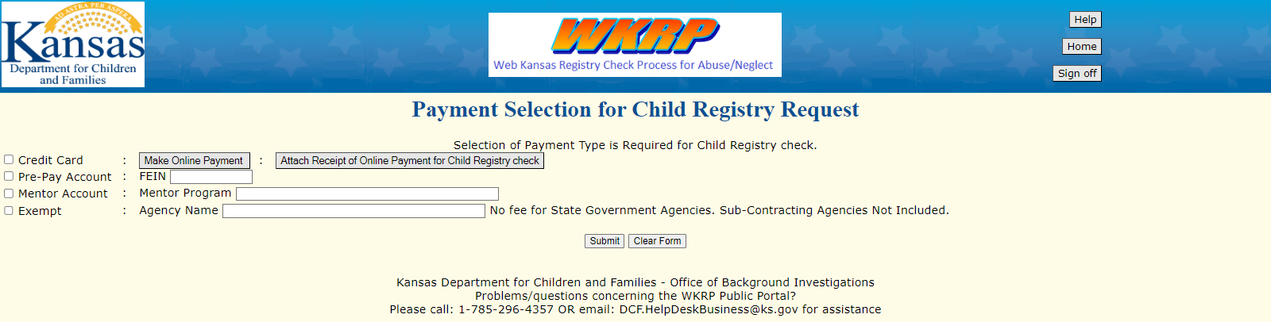
Payment Options: (Select Only One Box on the Far LEFT Side)
- Credit Card:
  - Press Link to payment site.
  - Save Receipt.
  - Upload Receipt (Can NOT move on unless Receipt is uploaded)
- Pre-Pay Account
  - If an Agency is paying for the Registry, enter the number they have provided to you: _____________________________________________
- Mentor Account:
  - Enter Name of Mentor Agency
- Exempt:
  - Only State Agencies are exempt. Sub-Contracting Agencies are NOT included and must pay the fee.

Information Collection Page: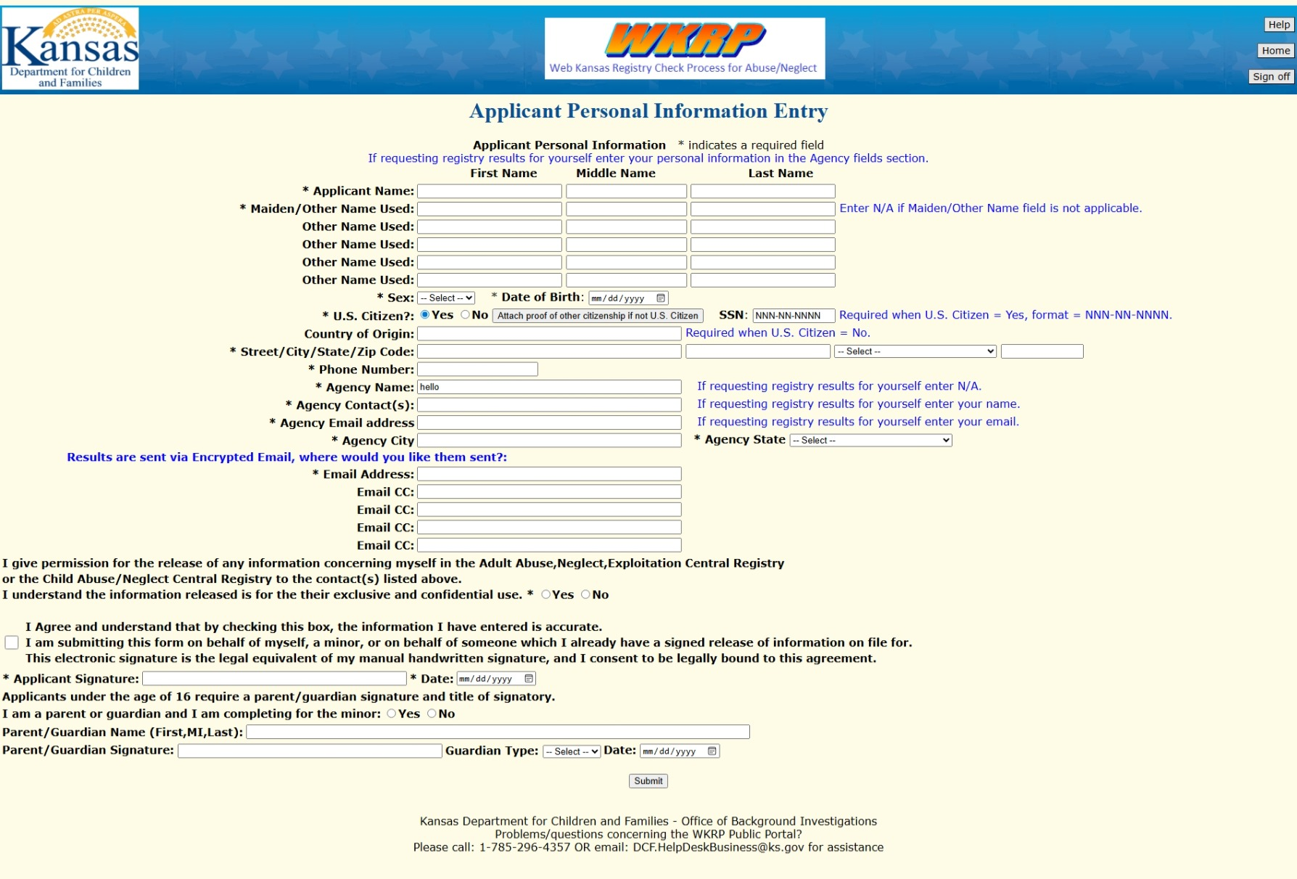
Notes on Information Collection:

- “Other Names Used”: Includes maiden names, married names, or aliases. If there are more than 5 additional names, another submission with additional payment must be made.
- Social Security Number is required. If the applicant is a non-citizen, please leave SSN blank and applicant must upload proof of citizenship from another country, or the software will not continue.
- You may list 5 email addresses. All addresses entered IN THIS SECTION will receive confirmation that DCF has received the submission. They will also receive the results via encrypted email.
  - _________________________________
  - _________________________________
  - _________________________________
  - _________________________________
  - _________________________________
Submission Email Confirmation:
Sample Verbiage of Emails received, once the form is submitted

“A request for background checks against the Adult and or Child Abuse Neglect Central Registry for __________________ (Name of person submitting the form), has been submitted for review by DCF Office of Background Investigation staff.
If your request is approved, it will be processed by DCF OBI Staff, and you will be notified with the results by encrypted email sent to the email address you provided.
If your Request is rejected, then you will be notified of the reason for the rejection by encrypted email sent to all email addresses you provided.
Please do not reply to this message”

Encrypted Email Results
- Results will be included in the verbiage in the body of the email, as well as an attachment in the form of a letter from Kansas DCF.

