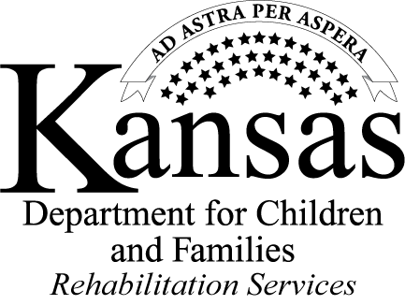
Work-Based Learning (WBL) Experience
CIL Self-Advocacy Report
Completed by CIL at the completion
Student Name: | Pre-ETS Transition Specialist:
WBL Provider Completing Report: | Dates of self-advocacy instruction:

Student mastered the following self-advocacy skills:
Student needs to work on the following self-advocacy skills:

Observations during self-advocacy instruction:
4/25/2017
Work-Based Learning (WBL) Experience
CIL Self-Advocacy Report -- Instructions
Pre-ETS Transition Specialist: Name of the Pre-ETS transition specialist working with the student.

WBL Provider Completing Report: Name of the service provider working with the student and completing report.

Dates of self-advocacy instruction: The dates self-advocacy instructions were given.

Student mastered the following self-advocacy skills: The skills the student obtained during the self-advocacy instructions.

Student still needs to work on the following self-advocacy skills: The skills the student was not able to master or obtain during the instruction. Provide information on the reason the student was not able to obtain the skill.

Observations during the self-advocacy instruction: Provide observations the self-advocacy instructor had regarding the student during the self-advocacy instruction. Attendance, interactions with instructors & participants, following instructions, staying on task, if accommodations or supports were discovered that are necessary for the employer site.

