When DCF is no longer the Representative Payee of a foster child’s benefit, the worker shall review expenses to ensure DCF has been reimbursed for cost of care to the extent that it can. Before closing out a case, all deposits must be approved or disapproved. Then, the worker shall notify the WARDS accountant to close out the WARDS account.

Step 1 Determine Dates DCF was Payee
This can be confirmed through review of the Social Security letters contained in the client’s WARDS file.
NOTE: If more than one set of payee date periods are involved, complete a separate worksheet for each period. Example: Child in custody and OOH placement from 11/1/14-1/31/19, but other payees were involved with the case and/or the benefits were suspended now and again during that history.
11/1/14-9/30/15 DCF Payee
10/1/15-5/31/16 relative payee
6/1/16-4/30/17 DCF Payee
5/1/17-7/31/17 benefit suspended
8/1/17-1/31/19 DCF Payee
Three separate PPS 5927B forms could be completed, one for each period DCF was payee.

Step 2 Confirm Approved Expenses Have Been Paid in Full to DCF
Run the Expense Detail report in WARDS for the dates involved in Step 1.

For this same example, the Expense Detail report appears below.
The App.Amt column represents the total amount the WARDS worker approved for this expense; the PaidAmt column represents the amount reimbursed to DCF.
Where PaidAmt column is less than the App.Amt column, DCF has not been reimbursed, or paid, in full.
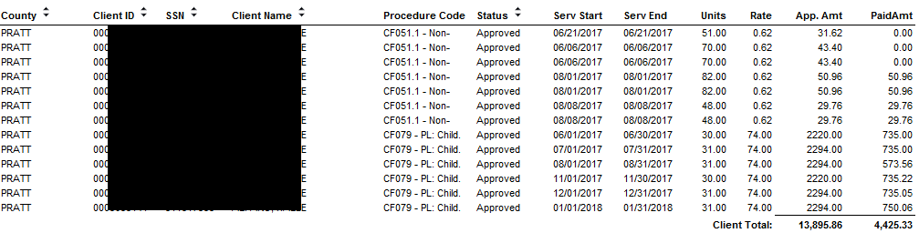
If expenses have not been paid in full, write the service ID#/amount NOT paid on the worksheet (write as many as occurred) and continue to the next step.

If all PaidAmts are the same as App.Amts there is no further reimbursement owed to DCF from this perspective. Proceed to next step.

Step 3 Check for Missing Months of Expenses
If there is still a balance in the client’s account after applying the unreimbursed expenses above (or if there were no unreimbursed expenses), complete form PPS 5927A and attach to this worksheet. If the outcome of PPS 5927A results in no further reimbursement possible, still attached the PPS 5927A.

Step 4 Request a Manual Expense
Complete request to WARDS Accountant at bottom of Worksheet and e-mail Worksheet(s) with attachments (if applicable) to WARDS Accountant.
NOTE: If all the expenses listed in Step 3 will apply to the amount being requested for the manual expense, for the Reason type: “All expenses on Step 3 apply.”

