



**What Will Happen?**

A Kansas Department for Children and Families (DCF) Prevention and Protection Services worker will assist you and your family to help identify the needs of your infant and family.

DCF may refer your family for Family Preservation Services or other community services.

Provider staff will work with you and your family to develop your Plan of Safe Care and help you set up the services and supports for your infant and family.

Your family has the right to refuse services. If you decide not to participate in services, DCF may assist you in finding other services to meet the needs identified in the Plan of Safe Care.

**KANSAS DEPARTMENT FOR**

**CHILDREN AND FAMILIES**

**CPS SPECIALIST NAME**

**PHONE**

**OFFICE**

# Department for Children

***ADDRESSING SUBSTANCE ABUSE WITH FAMILIES***

***PLAN OF SAFE***

***CARE***

and Families

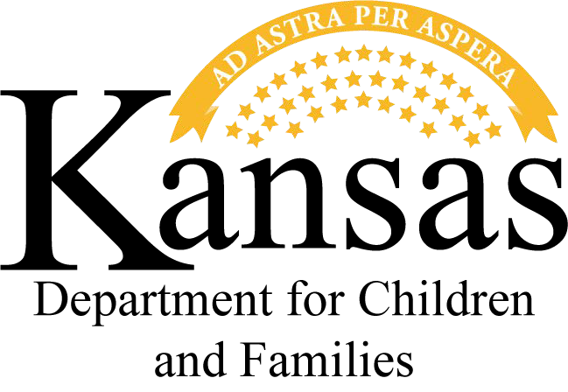State of Kansas

Department for Children and Families Prevention and Protection Services

PPS 2008

REV.- Jan. 21



**Who May Be Involved in a Plan of Safe Care?**

**What Does a Plan of Safe Care Include?**

The federal government passed the Comprehensive Addiction and

Recovery Act of 2016, (CARA) which added requirements for states through the Child Abuse Prevention and Treatment Act (CAPTA), to focus on the effects of substance abuse on infants, children and families.

The purpose is for early identification and intervention, by providing support for families needing help with substance use disorders, and setting up services and supports.

The goal of a Plan of Safe Care is to strengthen the family and keep the child(ren) safely in the home.

A Plan of Safe Care is an ongoing plan for the family that focuses on the infant’s ongoing health,

development, safety and well-being as well as the family’s physical/ social/emotional health; substance use disorder treatment; parenting ability; and readiness to care for the infant.

**What is a Plan of Safe Care?**

The Plan of Safe Care includes the following:

* The physical health, substance use disorder treatment

needs, general functioning, development, safety and any special care needs of the infant who may be having physical effects or withdrawal symptoms from prenatal exposure

* The physical/social/emotional health, substance use disorder treatment needs of the parent(s)/caregiver(s)
* Services and supports to improve the parent/caregiver’s capacity to nurture and care for the infant

The development of the Plan of Safe Care involves input from the mother, father and/ or other caregivers and uses a

multidisciplinary-team approach to provide coordinated and complete care. The team may include:

* Child welfare experts
* Medical staff
* Substance misuse disorder treatment professionals
* Mental health experts
* Early childhood intervention staff
* Home visitors
* Public health experts
* Others, as appropriate