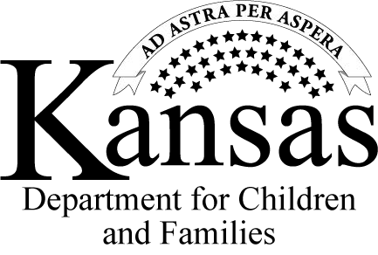
TO: Reporters Name
Street Address Street Address 2
City, State and Zip code

NOTICE TO REPORTER
PPS 1005
July 2020
Page 1 of 1

From: Kansas Protection Report Center RE: Event #
Thank you for contacting the Kansas Department for Children and Families (DCF) concerning child abuse or neglect on date. Some situations may not be assigned for further assessment. The incident or circumstance you reported was decision (assigned for further assessment OR not assigned for further assessment). If the incident or circumstance reported was not assigned, it is due to one of the following reasons:

Has been or is being assessed by DCF and/or law enforcement
Does not meet definitions for abuse or neglect by Kansas statute and regulation.
Information reported is the responsibility of another agency and has been forwarded.
Insufficient information to identify the alleged victim.

Federal and State laws protect the confidentiality of children and families by prohibiting DCF from disclosing additional details. DCF is unable to release further information to you without a written release of information.

If you need to make another report, contact Kansas Protection Report Center by:

- Telephone: 1-800-922-5330

- Web Intake: http://www.dcf.ks.gov/services/PPS/Pages/KIPS/KIPSWebIntake.aspx

- Fax: 1-866-317-4279

If you have a customer services concern, please contact DCF Customer Service at 1-888-369-4777.

