Your Rights During an Adult Protective Services Assessment
for Self-neglect
Your Rights During an Adult Protective Services Assessment
for Self-neglect
Your Rights During an Adult Protective Services Assessment
for Self-neglect

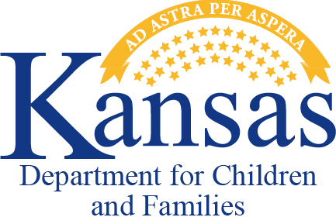The Kansas Department for Children and Families (DCF) Adult Protective Services (APS) is mandated by Kansas Law 39- 1433 to complete an assessment when a report of adult abuse, neglect or financial exploitation is assigned.
The Kansas Department for Children and Families (DCF) Adult Protective Services (APS) is mandated by Kansas Law 39- 1433 to complete an assessment when a report of adult abuse, neglect or financial exploitation is assigned.
The Kansas Department for Children and Families (DCF) Adult Protective Services (APS) is mandated by Kansas Law 39- 1433 to complete an assessment when a report of adult abuse, neglect or financial exploitation is assigned.

Your Rights
When you are involved in an APS assessment or a case is open for APS services, you have certain rights.
- The right to know there is an open case and the concerns.
- The right to direct your life to the best of your abilities.
- The right to be informed that APS must complete an assessment and may be required to take action to address immediate safety concerns.
- The right to have your confidential
information protected, as allowed by law.
- The right to discuss the situation with the APS Supervisor if you have concerns with the manner in which the assessment was conducted.
- The right to consent, withdraw consent, or refuse protective services interventions, unless there is a reason to believe there
is not capacity to consent. However, law enforcement may be notified to address immediate safety concerns.
- The right to have decisions made about you free from discrimination due to race,
religion, color, sex, disability, national origin or ancestry.
- The right to have any action taken by DCF staff on your behalf be no more restrictive than necessary.
- The right to know when the assessment is completed and the outcome.

PPS-10205 REV 07/21
Your Rights
When you are involved in an APS assessment or a case is open for APS services, you have certain rights.
- The right to know there is an open case and the concerns.
- The right to direct your life to the best of your abilities.
- The right to be informed that APS must complete an assessment and may be required to take action to address immediate safety concerns.
- The right to have your confidential
information protected, as allowed by law.
- The right to discuss the situation with the APS Supervisor if you have concerns with the manner in which the assessment was conducted.
- The right to consent, withdraw consent, or refuse protective services interventions, unless there is a reason to believe there
is not capacity to consent. However, law enforcement may be notified to address immediate safety concerns.
- The right to have decisions made about you free from discrimination due to race,
religion, color, sex, disability, national origin or ancestry.
- The right to have any action taken by DCF staff on your behalf be no more restrictive than necessary.
- The right to know when the assessment is completed and the outcome.

PPS-10205 REV 07/21

Your Rights
When you are involved in an APS assessment or a case is open for APS services, you have certain rights.
- The right to know there is an open case and the concerns.
- The right to direct your life to the best of your abilities.
- The right to be informed that APS must complete an assessment and may be required to take action to address immediate safety concerns.
- The right to have your confidential
information protected, as allowed by law.
- The right to discuss the situation with the APS Supervisor if you have concerns with the manner in which the assessment was conducted.
- The right to consent, withdraw consent, or refuse protective services interventions, unless there is a reason to believe there
is not capacity to consent. However, law enforcement may be notified to address immediate safety concerns.
- The right to have decisions made about you free from discrimination due to race, religion, color, sex, disability, national origin or ancestry.
- The right to have any action taken by DCF staff on your behalf be no more restrictive than necessary.
- The right to know when the assessment is completed and the outcome.

PPS-10205 REV 07/21

