Clear Cache from Browser
Clearing cache forces the browser to retrieve the newest copy of website content. Below are instructions for clearing cache in Chrome and Edge.
Steps to Clear Cache in Chrome:
To clear your browser cache in Chrome, click on the three-dot icon in the top-right corner of the browser window and go to More tools > Clear browsing data. Select the time range, check the boxes for clearing history and click on Clear data.
- Open Chrome.
- Click on the three-dot icon in the top-right corner of the window.
- Hover your cursor over More tools.
- Then click Clear browsing data.
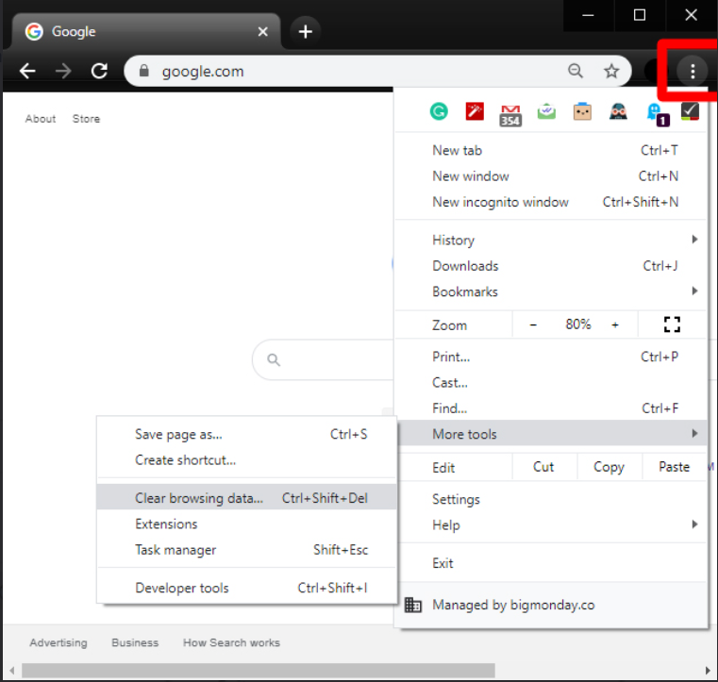
- Select All Time in the time range drop down.
- Check the boxes for
  - Browsing History
  - Cookies and Other Site Data
  - Cached Images and Files
- Finally, click Clear data. 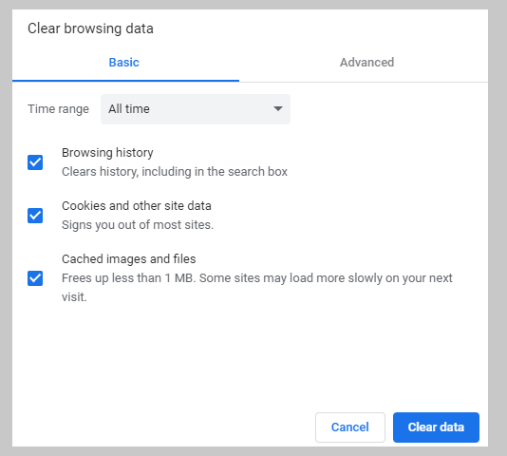

Steps to Clear Cache in Edge:
To clear your cache in Edge, click on the three-dot icon in the top-right corner. Then go to Settings > Privacy and services. In the Clear browsing data section, click Choose What To Clear. Select the time range, check the boxes for clearing history and click on Clear Now.
- Open Microsoft Edge.
- Click on the three-dot icon in the top-right corner.
- Then click Settings.
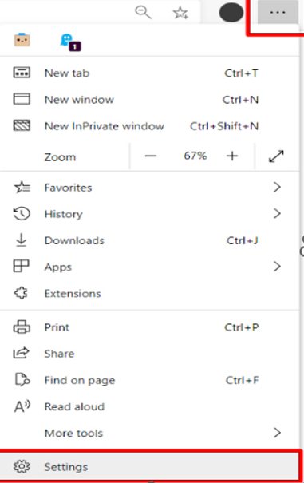

- Next, click Privacy, search, and services from the left sidebar.
- Then click Choose what to clear. You will see this under the Clear browsing data section.
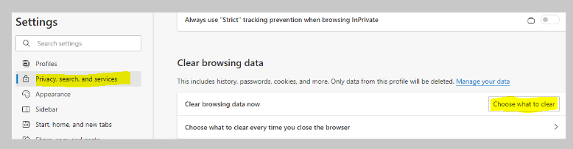
- Select All Time in the time range drop down
- Check the boxes for
  - Browsing History
  - Cookies and Other Site Data
  - Cached Images and Files
- Finally, click Clear Now
