[](http://srsshare.srs.ks.gov/)

**Kansas Department for Children and Families (DCF)**

**KAECSES - CSE System Re-Platform**

**Request for Information   
(RFI)**

Version: 1.0  
Date: 5/3/2019

RFI number: 2019-001

Contents

Executive Summary 3

Agency Overview 3

Project Goals 3

Projected Release Schedule 4

Technical Background 4

RFI Overview 7

Introduction and Purpose of the RFI 7

Scope of Work 7

RFI Process 8

RFI Response Guidelines 8

RFI Coordinator 10

RFI Schedule 10

Liabilities of Agency 10

RFI Ownership & Confidentiality 10

Exempt From Disclosure (Protected, Confidential, or Proprietary) 10

Appendix 1: Mainframe Legacy Business Applications 11

Appendix 2: Mainframe Database and Code Information 13

Appendix 3: KAECSES-CSE Child Support Ancillary Systems 15

**Executive Summary**

### The State of Kansas Department for Children and Families (DCF) Child Support Services (CSS) is currently seeking information from vendors regarding the replatforming of its current Child Support computer system to a more modern platform to better position itself to take advantage of the latest computer technologies.

**Agency/System Overview**

The Kansas Department for Children and Families (DCF) was established in 1937 as the State Welfare Office to participate in programs offered by the Federal Social Security Act and to establish programs for the care of the needy. In 1968, the State Legislature provided for the transfer of the Division of Vocational Rehabilitation Education Department to the State Welfare Office. In 1973, the State Legislature, pursuant to the Governor’s Reorganization order, created the Department of Social and Rehabilitation Services (SRS). In 2012, pursuant to the Governor’s Reorganization order, healthcare services and associated administrative duties were removed from SRS and the agency was renamed the Department for Children and Families (DCF). Today, DCF serves more than 500,000 Kansans. For more information, visit [***www.dcf.ks.gov***](https://dcfauth.dcf.ks.gov/)***.***

DCF serves children and families by providing services in offices and at access points located throughout the state. DCF is comprised of Economic and Employment Services (EES), Prevention and Protection Services (PPS), Rehabilitation Services (RS) and Child Support Services (CSS). Services are provided directly by the agency or through contracted providers and/or community partnerships. Work encompasses services to children, to families with children and to vulnerable adults or adults who have special needs. The overarching emphasis is to secure a safe, permanent and self-reliant environment for the individuals and families who are the agency’s clients. DCF’s CSS division is the lead program in the Request for Information and responsible for administering the IV-D program for the State of Kansas.

In carrying out their responsibilities, CSS relies upon a complex computer system certified by the federal Department of Health and Human Services (HHS) Administration for Children and Families (ACF) Office of Child Support Enforcement (OCSE). This system, the Kansas Automated Eligibility and Child Support Enforcement System (KAECSES), was certified as compliant with the Personal Responsibility and Work Opportunity Reconciliation Act of 1996 (PRWORA) in May 2002 and has been in operation relatively unmodified ever since.

KAECSES, while still functional, is cumbersome to maintain or enhance due to its aging platform and architecture. This system is unable to meet current program demands and requires extensive intervention by human resources to function on a day to day basis. The current system runs on an IBM Mainframe with a z/OS operating system utilizing Natural, Adabas, C#.Net, ASP.NET, SSRS, CA Gen (COBOL, CICS) and DB2. Given the aging software platform that is being utilized the State is seeking to implement a more modern platform that will enable utilization of the latest technologies to, overtime in future releases, capitalize on potential cost savings through increased automation, and incorporate industry best practices.

### Project Goals

The goal of this project is to convert the existing KAECSES-CSE mainframe system to a server-based accessible system, while either adapting the existing ancillary applications for the new server based KAECSES-CSE or replacing the ancillary applications with more compatible applications.

DCF is currently developing a project to implement a Commercial Enterprise Document Management system.  If project timelines allow, DCF would prefer to utilize the new Commercial Enterprise Document management system to replace the existing KESSEP Print document system. If the project timelines do not allow, DCF would like the vendor to recommend low cost options that could be made in the converted KAECSES-CSE system to facilitate operations and be easily transitioned when the future replacement of KESSEP Print with the Commercial Enterprise Document Management system.

Our expectations for the project are to convert the KAECSES-CSE mainframe system to a .Net / SQL Server system with a user interface and eliminate the use of mainframe for KAECSES-CSE. The ability to retain and/or retrain existing CA:GEN developers to support the converted system is highly desirable to avoid a sudden loss of system business knowledge.

Project Requirements supporting these goals are:

1. User interface
2. Microsoft .Net / SQL Server / Windows Server platform
3. Transition period allowing continued CA:GEN development to utilize existing developer resources with ongoing conversion along with .NET development
4. Integration with Ancillary applications such as portals, document management system
5. Integration with MPI (Master Person Index).
6. Support Security Requirements both Federal and State.

With this migration, DCF intends to change the underlying technology only, not the functionality of the system. Fundamental business rules/processes are not intended to change.

### Projected Release Schedule

Once migration to a new platform is completed, subsequent modernization projects will be undertaken to align the system with current and future business needs.



### Technical Background

Current applications reside on either a mainframe (IBM Z/OS) or a server platform. The mainframe applications were developed using either CA:GEN COBOL, CICS/COBOL, or a combination of these. Current web applications are predominately .Net (C# and ASP.Net) running on Windows server using Attunity and/or CA:Gen Com proxy for DB2 Access.

There are also some smaller.NET applications running on Windows servers. The Database being utilized is DB2. See *Appendixes 1 through 3 for application details* (that will be included in this conversion).

The core business applications are mainframe applications that have been in existence for up to 20 years and support DCF Child Support Services core business programs. These applications are comprised of both online and batch functionality. Source code repositories include Librarian for COBOL modules, and the CA:Gen libraries and models. Development staff use ROSCOE, TSO, and the CA:Gen toolset for development work on the mainframe and Visual Studio with Attunity (for DB2 connectivity) in the server environments. See *Appendixes 1 through 3 for application details*.

Additional system software is utilized in support of the core business applications: Rocket BlueZone; Attunity; BMC; CICS; Cyberfusion; GoldenGate; Job Track; TMON; Top Secret; Version Control log; and, Visual Studio with Team Foundation Server.

The primary databases DCF Child Support Services uses to manage and store its mainframe data is DB2.

Interfaces are a critical component to the operation of DCF Child Support Services systems and are responsible for the collection and sharing of data that is vital for effective and efficient operation of DCF Child Support Services programs in a reliable, accurate, and timely manner.

Interfaces enable the exchange of data between systems within DCF, with other State Agencies, Federal Government entities, and other interested parties; community-based organizations, service providers, and contractors.

Kansas DCF Child Support Services KAECSES-CSE mainframe applications are hosted / operated by Ensono.

Figure 1, below, shows the flow of information within the current technology.

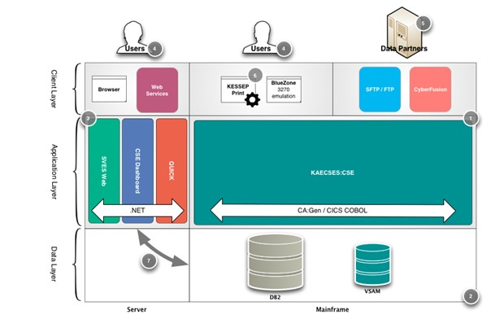

Figure 1: Flow of Information within Current Technology

1. On the right (mainframe) side, the core of the system is the KAECSES-CSE mainframe system, written primarily in CA:GEN COBOL and CICS COBOL.
2. Also, on the right is the core database, which is hosted on the mainframe in DB2.
3. On the middle-left is a small collection of ancillary applications. Most are written in .NET.
4. On the top of the diagram are users. Most are human users, who access the system via either a Web browser (in the case of the ancillary applications in particular), or via a 3270-terminal emulation application (Rocket BlueZone is the current standard).
5. Other systems that trade data with the IV-D system are shown as “Data Partners” in the client layer. With most interfaces being built on file transfers, the primary way of trading data with partners is through File Transfer Protocol (FTP), Secure File Transfer Protocol (SFTP), or proprietary file-exchange tools such as CyberFusion.   
   The MPI (Master Person Index) data exchange utilizes DB2 to sync/exchange data with other DCF programs using GoldenGate middleware.
6. KESSEP Print is shown as a client-layer element because it functions by “impersonating” a human user (screen scraping), but then secondarily processing the data it downloads (choosing a locally-stored MS Word template and merging data with it). This print process also has a server-based batch print feature to handle bulk document printing. From this diagram’s perspective, it is just another client, however.
7. Note that the absence of a database for the server side does not indicate the absence of a data layer, but rather that all data are stored in the primary databases that reside on the mainframe side. Native database drivers and middleware products such as Attunity and COM Proxy provide the non-mainframe applications access to the data they need.
8. *Special note concerning data export and conversion; portions of data relationships are defined and enforced in the CA:GEN models, while additional data relationships are defined and enforced in DB2.

Current System Scope

The IV-D system includes functionality for case initiation, location of noncustodial parents, establishment of paternity and support, enforcement of support, and distribution of support payments. Figure 2, below, shows the major areas of functionality within the current IV-D system.

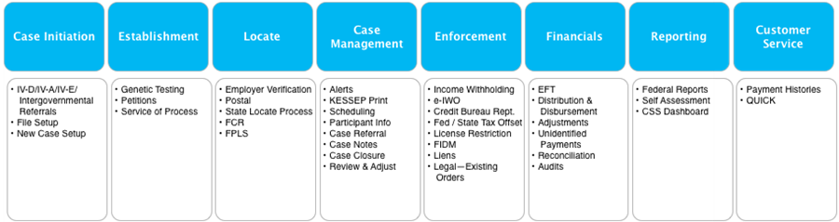

Figure 2: Functional Elements Supported by the Current Technology

Batch Interface flow.

Figure 3, below, shows the flow of information between the IV-D system and the primary data partners.

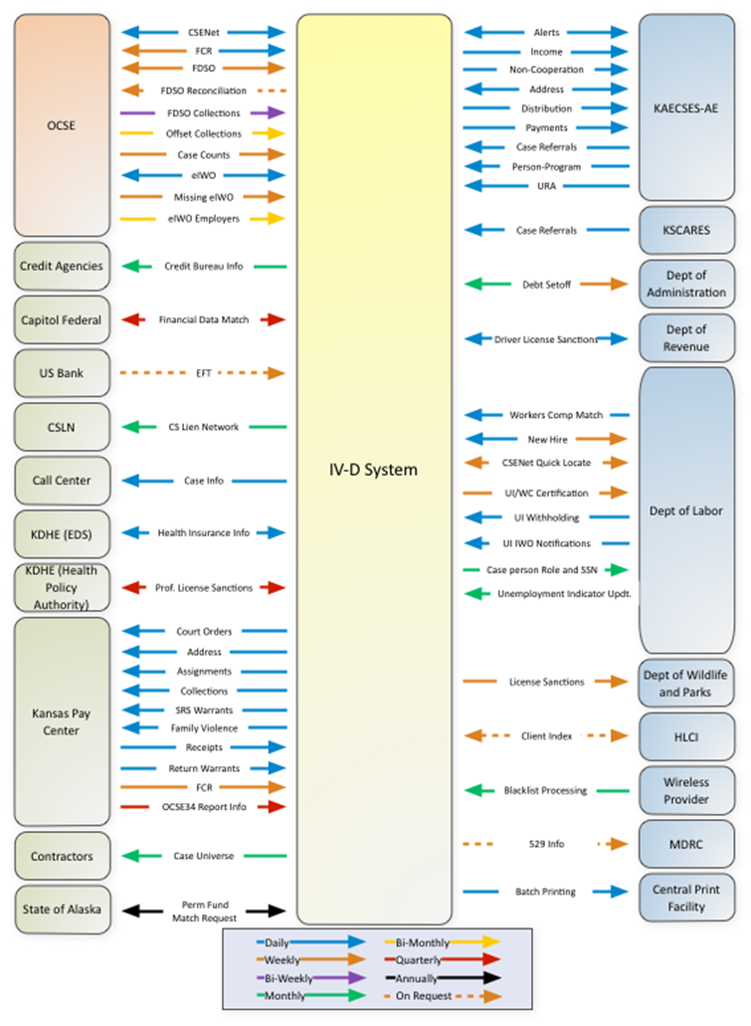

Figure 3: Interfaces Between IV-D System and Primary Data Partners

# RFI Overview

### Introduction and Purpose of the RFI

The purpose of this is to solicit information regarding transferring the Kansas DCF Child Support Services KAECSES-CSE system from our current CA:Gen/Cobol/DB2 platform to a more modern .Net / SQL Server platform providing a user interface. DCF is requesting information on recommended migration services and methodologies from vendors with experience in successfully implementing similar technology migration projects. DCF is particularly interested in information that can be provided for successful migration projects performed in a government environment.

DCF requests a non-binding rough order of magnitude estimate for the length and cost of the proposed migration services and of any licensing fees vendors believe would be associated with the migration services proposed (See the previously mentioned attached appendices that can assist in estimating the cost). DCF intends to use the information from this RFI to educate itself on migration options available for a technology migration project to meet its stated goals.

### Scope of Work

Provide conversion and consulting services/products to facilitate Kansas DCF KAECSES-CSE’s retirement of its mainframe legacy system through code and database conversion of its existing systems to a more modern .Net/SQL Server platform. A vendor will be responsible for leading efforts to:

* Devise the overall approach, create and execute the overall project schedule.
* Develop the system hardware and software specifications (including support and middleware applications) and architecture.
* Provide hosting recommendations/options that would include, at a minimum, the system being hosted at the State of Kansas data center provided and managed by Unisys.
* Provide code and data conversion (including code and data conversion tools).
* Conduct unit and system integration conversion testing.
* Conduct system performance testing.
* Facilitate user acceptance testing.
* Facilitate State Security Requirements.
* Provide go-live support.
* Provide a limited period of post go-live suport.
* Deploy the converted system.
* Decommission the legacy systems.
* Provide recommendations for State staffing level requirements for the new system/platform and roles/skills/skill level as well as ancipated timeline/resource support participation from the vendor following the converted systems go-live.
* Provide Technical Knowledge transfer activities.

Our expectation is that apart from a new database and operating environment, the migrated system will be functionally equivalent to the existing system. The existing interfaces on the partner side would also be expected to work the same as they do now, so that interface partners are not impacted by this migration. DCF’s goal is for DCF business operations and its partners to experience no interruption in system services, and after migration, for the existing technical and operational staff to be trained to maintain and enhance the system on the new platform.

# RFI Process

Follow the RFI Response Guidelines to answer this RFI.

### RFI Response Guidelines

1. Company name

Company address

Contact person responsible for answering this RFI, Telephone and Email

1. Vendor Experience (Optional)
   1. Please provide information on private or public sector organizations that have previsouly utilized your migration services and are currentlly using a system you migrated from a legacy mainframe environment. Plese provide system sizing information for the migrated system(s) and contact information for those organizations if available.
   2. Please share your organization’s expereince with the following types of conversion projects:
      1. Converting CA Gen/CICS/COBOL/DB2 system to Microsoft .Net platform;
      2. Converting Child Support Systems; and/or
      3. Converting State of Kansas systems.
   3. Do you believe experience with Child Support Enforcement systems is beneficial? Why or why not? If not, how would you compensate for the potential lack of business knowledge?
2. All articles requested in the Scope of Work:
   1. Description of overall approach:
      1. Provide expectations of preliminary work expected to be performed by the state prior to vendor starting the project
      2. Provide a description and explanation that will allow DCF to understand the general nature and architecture of the software migration and hardware approach being recommended. Literature, specification sheets, handouts, and other pertinent information may be included directly in your response or submitted as an attachment.
      3. Discuss the limitations vs. opportunities for modifying the user interface of the migrated system. Topics should include, but not necessarily limited to:
         1. Will the user interface of the migrated system be the same as the interface in the old system, or are there opportunities to make modest changes to the UI without affecting the functional equivalent system?
         2. Discuss any additional costs and risks that would be introduced with such modest changes.
         3. Discuss the extent ADA usability requirements can be accommodated with your migration methodology.
         4. Discuss the extent Security requirements can be accommodated with your migration methodology.
      4. Discuss the limitations vs. opportunities for application restructuring and code clean-up. Topics should include, but not be limited to:
         1. What code restructuring issues can be dealt with within the scope of the conversion project?
         2. What code restructuring issues cannot be dealt with in the scope of the conversion project?
         3. How are the costs and risks of the project affected by code restructuring?
      5. High level map/diagram indicating what the current database, applications, platforms and data could be converted to.
   2. A high level project schedule with estimated implementation time and costs incrementally by system.
   3. Technology platform(s) for the new enviroment:
      1. Future Database sizing recommendations (including specifics such as version, size, etc.)
      2. Future Application recommendations (including specifics such as version, type, etc.)
      3. Products to be used for code and data conversion for all environments:
         1. Production
         2. Development
         3. Staging
         4. Acceptance
         5. Training
      4. Hardware for all new environments required:
         1. Production
         2. Development
         3. Staging
         4. Acceptance
         5. Training
      5. Software for all new environments required:
         1. Production
         2. Development
         3. Staging
         4. Acceptance
         5. Training
   4. Provide your recommended testing requirements and approach:
      1. Discuss how testing of the migrated system will take place in your recommended migration methodology
      2. Describe automated vs. manual testing in your recommended methodology and the tools required
      3. List all expectations of DCF, i.e., staff requirements, tools to-be-purchased, etc.
   5. Provide your overall expectations for participation of DCF technical teams and program staff, considering DCF’s plans to support the newly migrated system with in-house resources:
      1. Project Team roles and number
      2. Project Team role descriptions
      3. Addtional staff required and level of effort: subject matter experts; stakeholders and technical staff
   6. Training for DCF staff:
      1. Recommendations for technical staff by role
      2. Recommendations for end users
   7. On-going maintenance:
      1. Recommended maintenance approach, i.e., State staff, hosting, Cloud, etc. with estimated cost levels
      2. Recommended number of state staff by role and skill level
      3. Estimated costs for software licenses and upgrades
      4. Recommended Hardware Upgrade cycle and costs
3. Identify Recommended Security methods and any supporting software or hardware required.
   1. IRS, OCSE, FTI related data, SSA, NIST Standards...
   2. State of Kansas Requirements (will make available)
   3. Cloud Environment
   4. Fed Ramp
4. Identify all assumptions made in developing the RFI.
5. Document any potential risks identified during development of the RFI.
6. Any additional items or recommendations believed necessary for DCF to consider.
7. Attach any supporting documentation.

Responses should be limited to 100 pages maximum, 50 pages of narrative and 50 pages for appendices. Send the response in word-format and any additional response by email to the RFI Coordinator.

### RFI Coordinator

### Linda Cambron, Deputy Director of Operations

### 555 S Kansas Ave, 5th Floor

### Topeka, KS 66603

### Email: [Linda.Cambron@ks.gov](mailto:Linda.Cambron@ks.gov)

### RFI Schedule

This is the timeframe for the RFI and an eventual coming project

05-03-2019: RFI released

05-15-2019: Last date for questions

06-03-2019: Last date for submission of information

### Liabilities of Agency

This RFI is only a request for information about potential products/services and no contractual obligation on behalf of the Kansas Department for Children and Families whatsoever shall arise from the RFI process.

This RFI does not commit the Kansas Department for Children and Families to pay any cost incurred in the preparation or submission of any response to the RFI.

### RFI Ownership & Confidentiality

***RFI Ownership:*** All responses to the RFI will become the property of the Kansas Department for Children and Families and will not be returned.

***Open Records Act****:* Under the Kansas Open Records Act (reference K.S.A. 45-215) all materials received or created by DCF are considered ***public records***. These records include but are not limited to proposal submittals, agreement documents, contract work product, or other information submitted by an applicant to DCF.

The State of Kansas Open Records Act requires that public records must be promptly disclosed by DCF upon request unless those records are excluded in accordance with K.S.A. 45-221 (27)n (Specifications for competative bidding, until the specifications are officially approved by the agency).

### *Marking Records Exempt From Disclosure (Protected, Confidential, or Proprietary):* If you believe any of the documents you are submitting to DCF as part of your informational material are exempt from disclosure due to patent or proprietary issues, you can request they not be released. To do so, identify which areas are confidential and the reason why.

Only the specific records or portions of records properly identified will be protected and withheld for notice. All other records will be considered fully disclosable upon request.

By submitting a response to this RFI, Respondent acknowledges this obligation; and also acknowledges that DCF will have no obligation or liability to the proposer if the records are disclosed.

***If you have any questions about disclosure of the records you submit with your informational material, please contact the RFI Coordinator.***

# Appendix 1: Mainframe Legacy Business Applications

**KAECSES-CSE On-Line system**

**Kansas Child Support System Overview**

KAECSES-CSE was originally developed in the early 1990’s on a OS/390 mainframe platform using CA-GEN CICS/COBOL and IBM DB2. Over the years, KAECSES-CSE has received minimal upgrades including moving from OS/390 to Z/OS and the addition of ancillary applications utilizing Microsoft technologies such as ASP.Net and C# accessing KAECSES-CSE data via Attunity server which supplies ODBC to DB2 and CA-GEN Com-Proxy which exposes CA-GEN processes as services. Microsoft SQL Server Reporting Services provide web-based reporting features via Attunity server which supplies ODBC to DB2. Most recently, KAECSES-CSE has been integrated into a Master Person Index utilizing DB2 tables for real-time, bi-directional exchange of demographics and program participation information with other DCF systems.

**KAECSES-CSE Batch Interfaces**

KAECSES-CSE utilizes batch interfaces to regularly exchange data with Federal, State and Private partners. These batch interfaces are critical to the operation of Child Support Business and technical processes. KAECSES-CSE batch file exchanges utilize secure FTP to transfer data files.

KAECSES-CSE currently utilizes ninety batch interface jobs to exchange data with our private and public business partners. Each batch job may contain multiple job steps executing programs and/or system utilities such as system file sorts, FTP, etc.

Code conversion of these batch processes will be critical to the project to ensure smooth, reliable automated performance of these data interfaces. Interface failures can result in unrecoverable loss of child support collections/intercepts, delayed payments to custodial parents, delays in absent parent locations. Poor performance or failures can result in federal penalties and loss of funding for Kansas Child Support Services.

**KAECSES-CSE System Diagram including environments, ancillary applications and technologies**



# Appendix 2: Mainframe Database and Code Information

|  |  |  |  |  |  |  |  |  |  |
| --- | --- | --- | --- | --- | --- | --- | --- | --- | --- |
| ***CA:Gen Model Name*** | ***Online Processes (Psteps)*** | ***Batch Processes (Psteps)*** | ***Server Procedures (Coop)*** | ***Action Blocks*** | ***External Action Blocks*** | ***Z/OS DB2 Tables*** | ***Screens*** | ***.NET Web Pages*** | ***XML*** |
| KAECSES-CSE PRODUCTION | 425 | 324 | 10 | 2,444 | 246 | 339 | 419 | 0 | 0 |
| SVES & QUICK .NET web app using CA:Gen Servers | 11 | 0 | 11 | 13 | 1 |  | 0 | 15 | 7 |
| HELP PRODUCTION | 11 | 2 | 13 | 29 | 12 | 5 | 11 | 0 | 0 |
| PURE COBOL & DB2 Programs (Reports, Ext, update) | 933 (B & O) | 132 | 0 | 0 | 0 |  |  | 0 | 0 |
| DB2 Triggers (Batch & Online) | 754 |  |  |  |  |  |  |  |  |
| Common Action Blocks (CSS shared with FACTS) | 1,222 | 1,222 | 0 | 4 | 4 | 3 | 0 | 0 | 0 |
| ***Total Objects*** | ***416*** | ***466*** | ***10*** | ***2,216*** | ***245*** | ***347*** | ***427*** | ***15*** | ***7*** |

**The KAECSES-CSE Mainframe system production environment estimates include:**

|  |  |  |  |  |  |  |  |  |
| --- | --- | --- | --- | --- | --- | --- | --- | --- |
| ***CA:Gen Model Name*** | ***Online Processes (Psteps)*** | ***Batch Processes (Psteps)*** | ***Pure Cobol & DB2 Programs*** | ***Action Blocks*** | ***External Action Blocks*** | ***Z/OS DB2 Tables*** | ***Z/OS DB2 Triggers*** | ***Screens*** |
| KAECSES-CSE DEVELOPMENT | 475 | 400 | 1125 | 2456 | 290 | 343 | 756 | 449 |
| KAECSES-CSE ACCEPTANCE | 406 | 365 | 864 | 2231 | 298 | 342 | 752 | 431 |
| KAECSES-CSE TRAINING | 420 | 339 | 168 | 2183 | 265 | 340 | 752 | 423 |
| KAECSES-CSE LEGACY | 412 | 330 | 487 | 2113 | 253 | 331 | 741 | 415 |
| KAECSES-CSE INTERFACE | 405 | 341 | 502 | 2121 | 257 | 332 | 742 | 416 |
| KAECSES-CSE SYNC | 432 | 331 | 389 | 2210 | 301 | 336 | 741 | 428 |
| KAECSES-CSE PRODUCTION FIX | 425 | 335 | 168 | 2456 | 290 | 341 | 755 | 426 |
| ***Total Objects*** | **2975** | **2441** | **3703** | **15770** | **1954** | **2365** | **5239** | **2988** |

**The KAECSES-CSE Mainframe system non-production environment estimates include:**

**The KAECSES-CSE DB2 Database storage statistics:**

|  |  |  |
| --- | --- | --- |
| **Region** | **Number of Tables** | **Number of bytes** |
| Production | 347 | 136,992,344,445 |
| Acceptance test | 356 | 672,255,622 |
| Development | 360 | 681,852,790 |
| Production fix | 349 | 65,182,296,983 |
| Sync | 334 | 68,144,464,417 |
| Legacy | 364 | 6,010,388,266 |
| Interface | 337 | 569,735,091 |

# Appendix 3: KAECSES-CSE Child Support Ancillary Systems

Overview of the KAECSES-CSE Ancillary systems

**\*Microsoft applications**

* Desktop documents – Technologies
  + KESSEP Print application
    - This desktop application is used for local printing and the updater that retrieves updated MS Word form files.   
      Document Updater interaction: This Dynamic Link Library (DLL) is used to enable an application to provide automatic updating capabilities. Specifically, this allows KESSEP Print.exe to check for, download and install updated documents and program files without technical staff or field staff intervention. The DLL is referenced by the KESSEP Print.exe application and is not a standalone program.
    - KESSEP Print is a C# Windows 7 desktop application, which utilizes Extra/Reflections API,’s to perform 3270 screen scrapings of KAECSES-CSE mainframe to produce MS Word documents merged with KAECSES-CSE data that are editable on the local desktop.
    - Reflections 3270 emulator
    - C#.Net
    - CA:GEN Com-Proxy
  + Document updater
    - This application allows business staff to create new MS Word document templates that incorporate mainframe KAECSES-CSE data into the document when printed on the local users’ desktop or in the batch environment.
    - This Dynamic Link Library (DLL) is used to enable an application to provide automatic updating capabilities. Specifically, this allows KESSEP Print.exe to check for, download and install updated documents and program files to the user’s local desktop without technical staff or field staff intervention. The DLL is referenced by the KESSEP Print.exe application and is not a standalone program.
  + Batch document processing
    - Windows Server
    - C#.Net Services
    - The batch document processes utilizes CA:GEN Com-Proxy to retrieve data from the KAECSES-CSE system and merge data into MS Word using MS Word document templates documents for batch printing. These documents include legal documents, customer correspondence, special mailings, etc. The batch process utilizes email to notify individual users of pending documents (to allow users to cancel if desired) and completed documents.
  + CSS Dashboard
    - A high-level set of reports developed in SQL Server Reporting Services (SSRS), accessible by authorized users, based on transactional data for CSS program outcomes and operations. This allows monitoring of federal incentive measures at various reporting levels to assist management in performance improvement. The Dashboard utilizes Attunity for access to Mainframe DB2 KAECSES-CSE data.
* Web based systems that access KAECSES-CSE using CA:GEN Com Proxy
  + SVES Web
    - This application retrieves SVES response data from the KAECSES-CSE system using CA:GEN Com Proxy and displays it through web pages. Processing is handled by the legacy.
    - ASP.NET
    - C#
    - MVC
  + QUICK
    - Provides responses on Kansas cases to requests received though the OCSE State Services Portal.
    - ASP.NET Web API
    - SOAP Web Services
    - C#